**Create High Availability Hadoop Cluster-**

1. Configure three machines with selinux diables, ipv6 disabled , iptables off, NetworkManager off, network on,etc. (this part is covered in the vm setup file uploaded in this repository)





1. Download Cloudera Manager for centos. Link ***archive .cloudera.com/cm5***

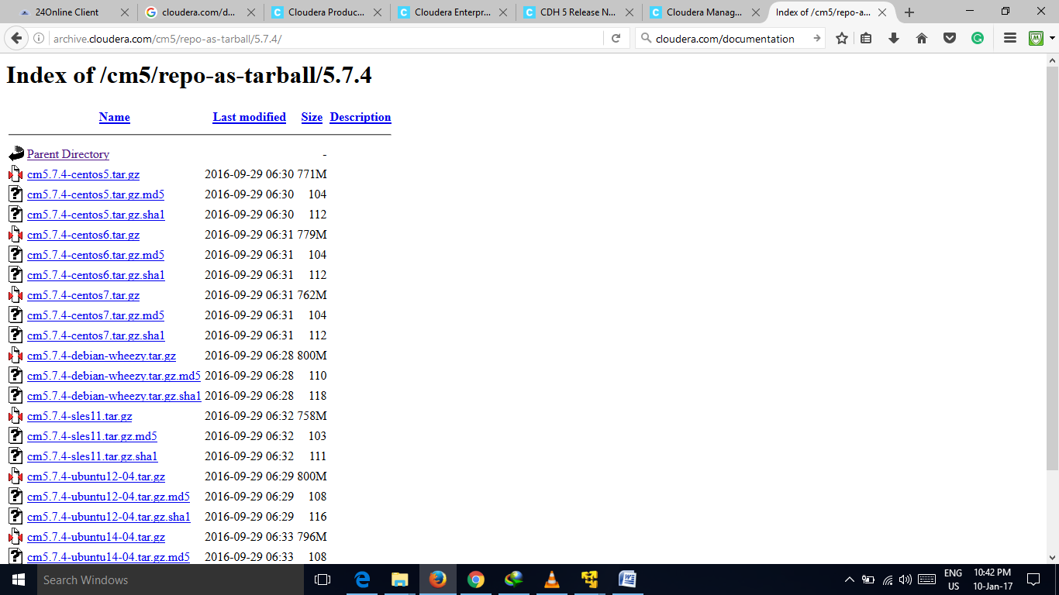

1. Download CDH (Cloudera Distribution Including Apache Hadoop). Link ***archive.cloudera.com/cdh5*** download the parcels

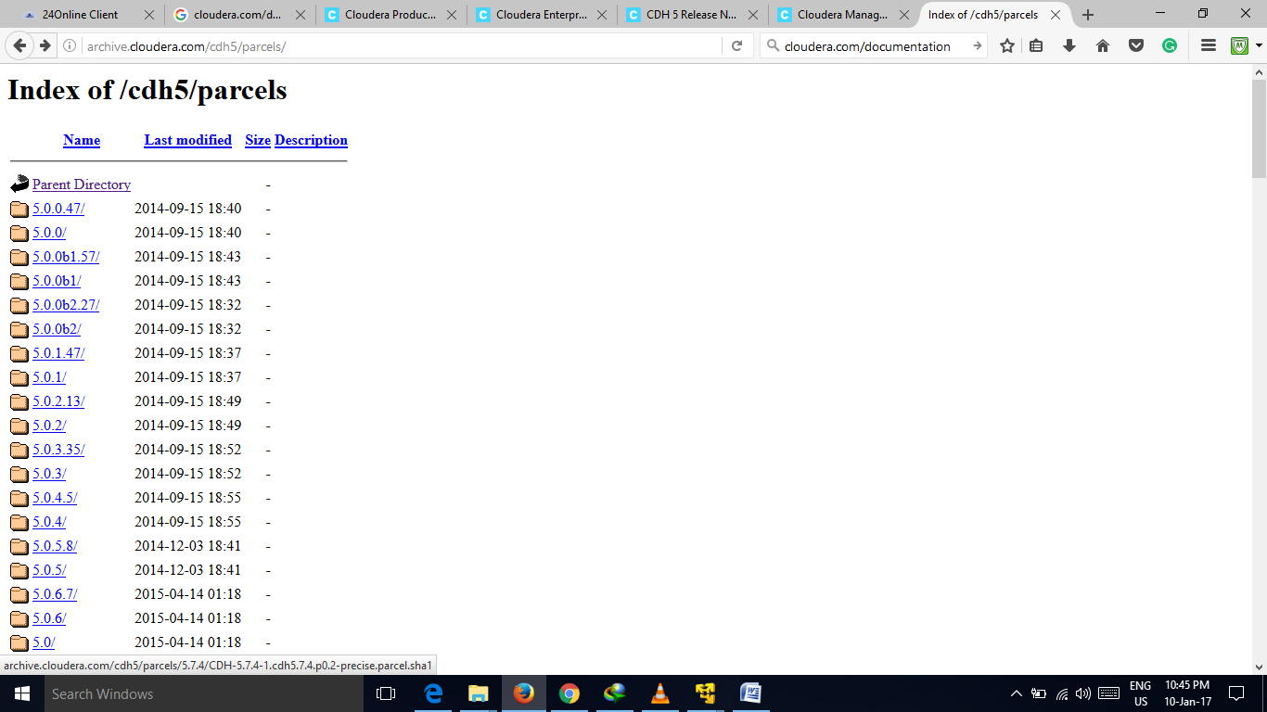

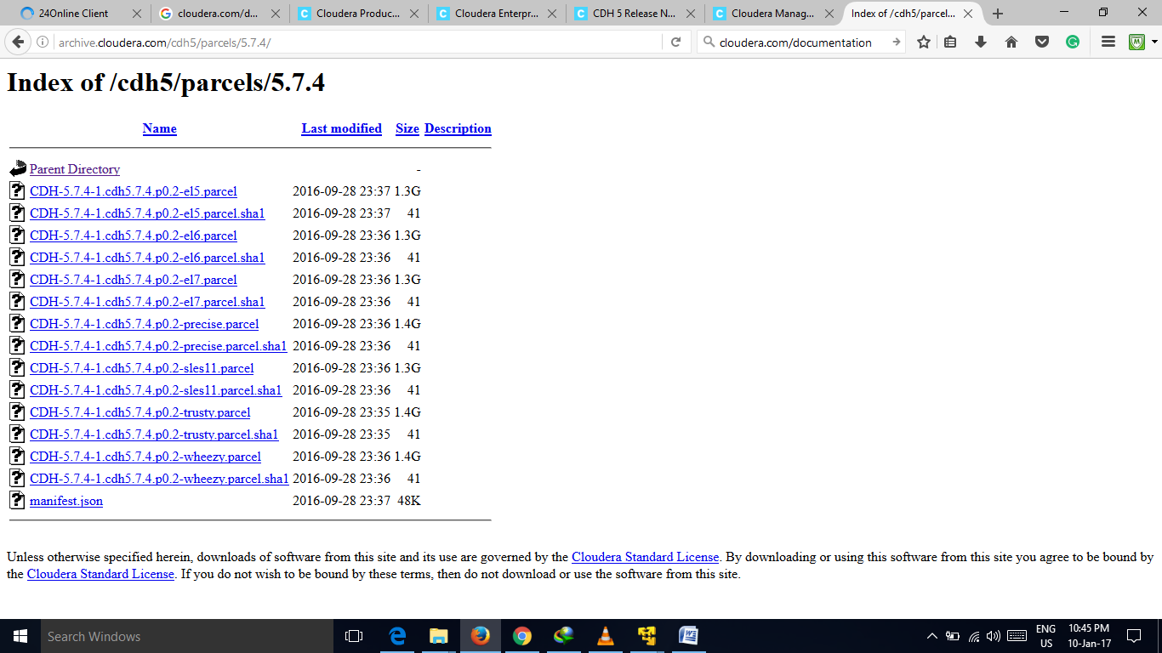

1. VM infrastructure

CDH1= cloudera manager, master node1,datanode 1, edge node(client node) 4 Gb Ram Used

CDH2=master node2, data node2 2.5 Gb Ram Used

CDH3=master node 3, data node 3 2.5 Gb Ram Used

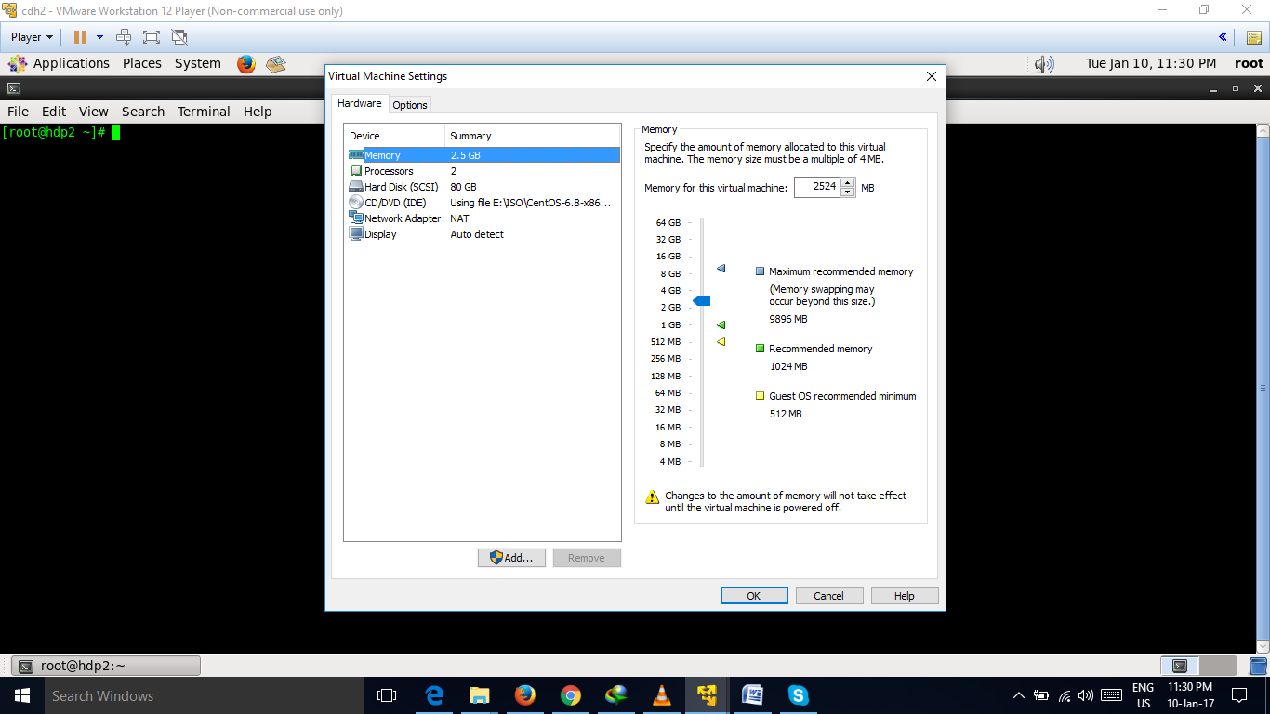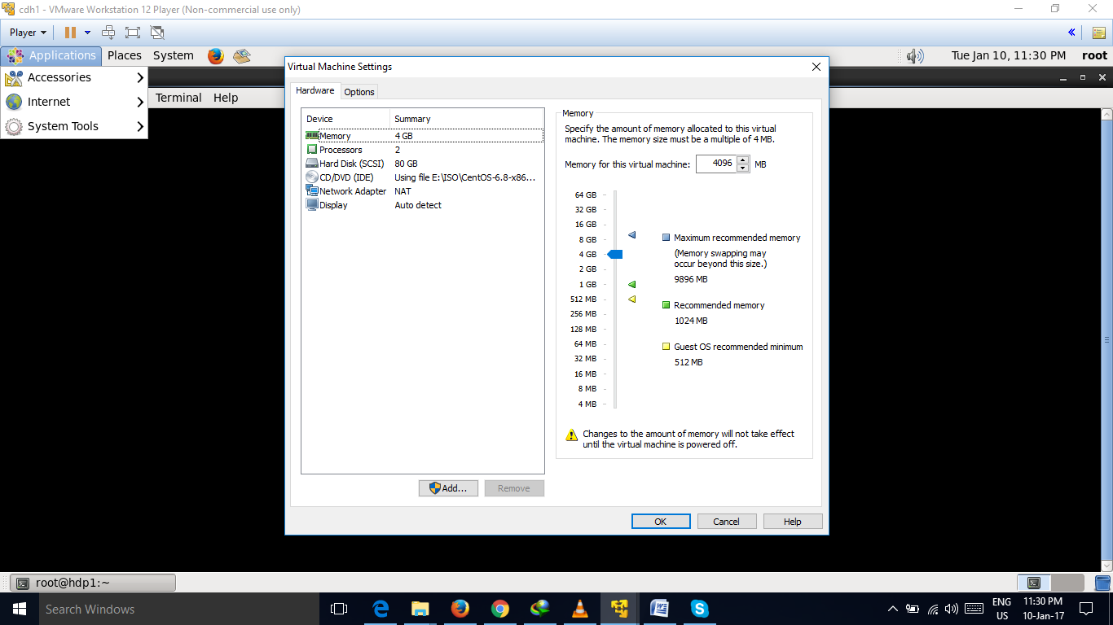

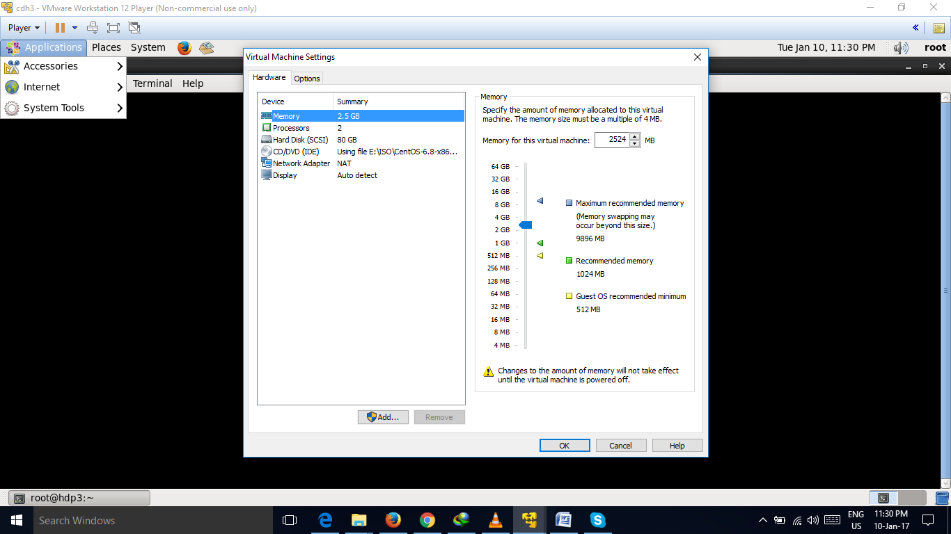

1. Three mandatory packages base, epel , extras.

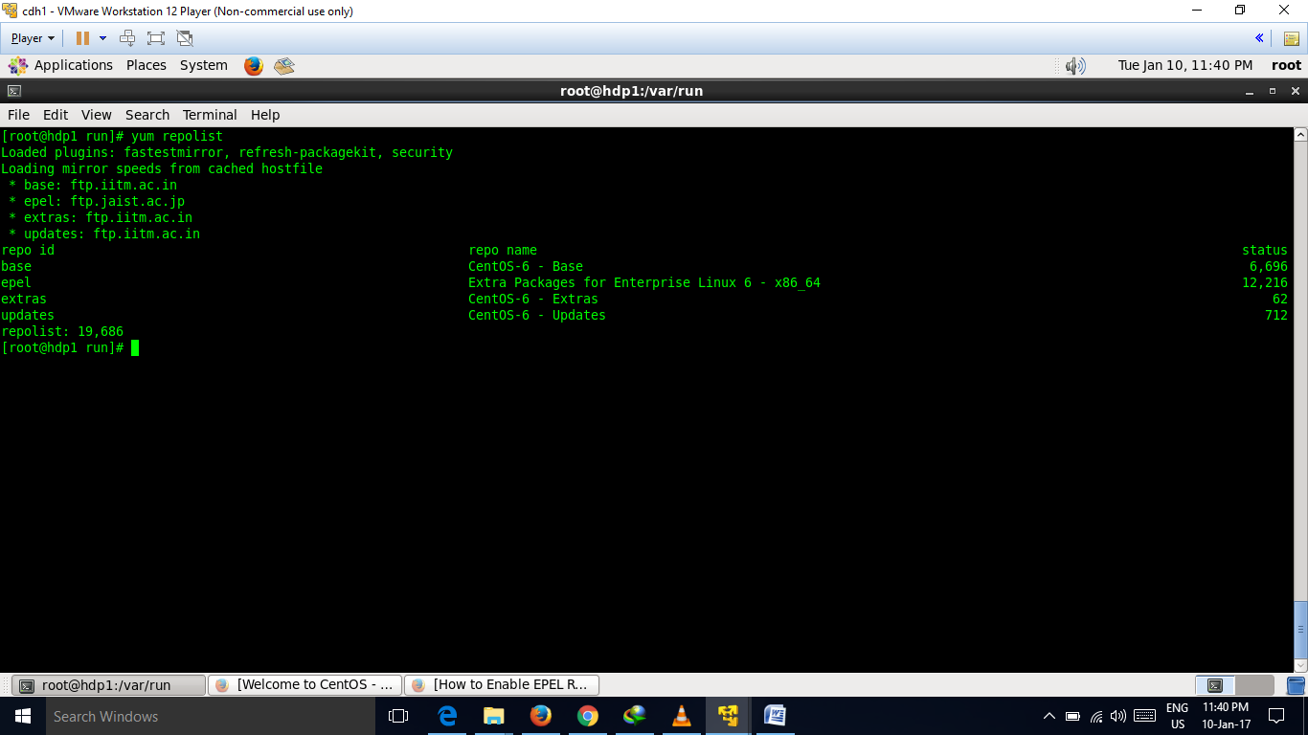

1. Run ifconfig command to check the ipaddresses. 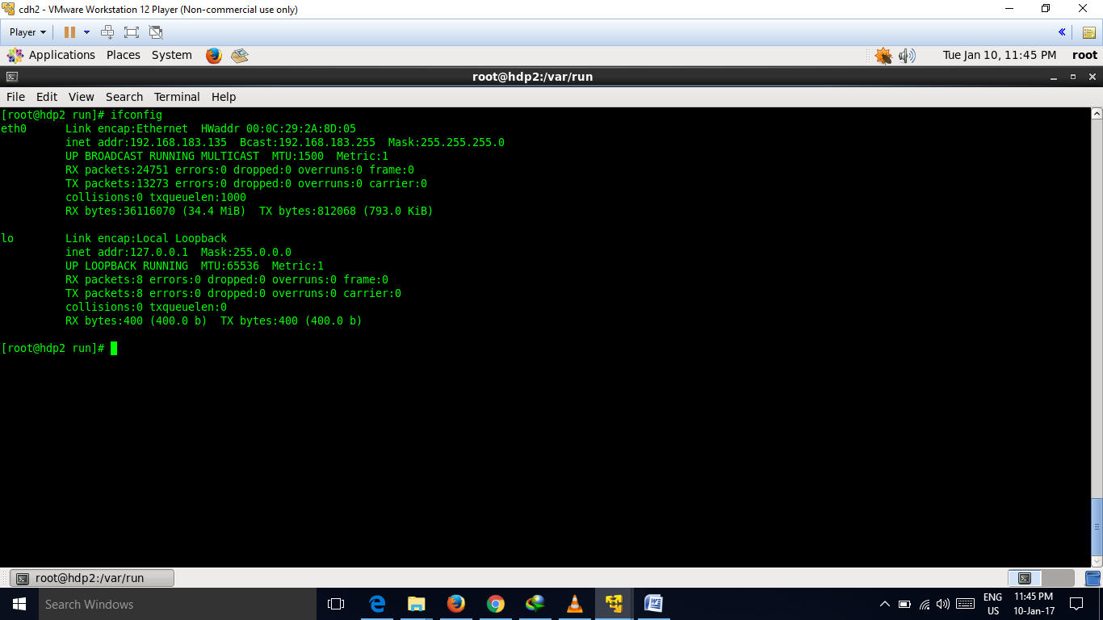

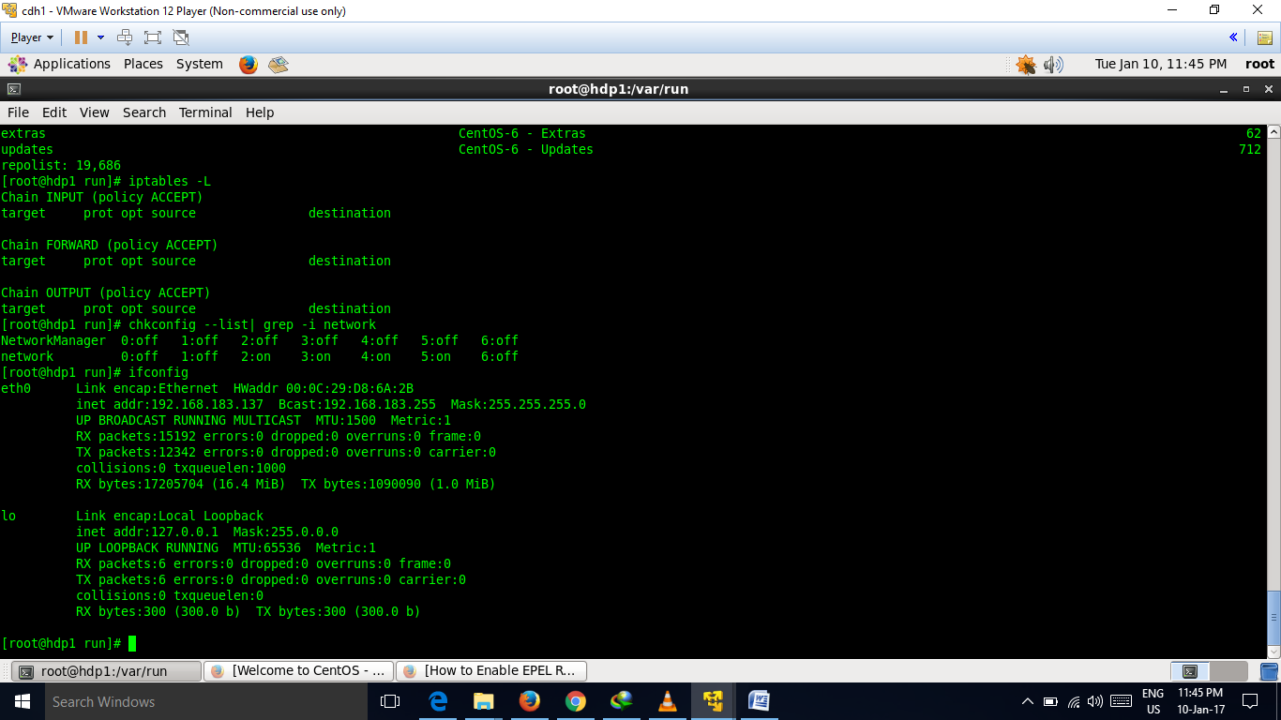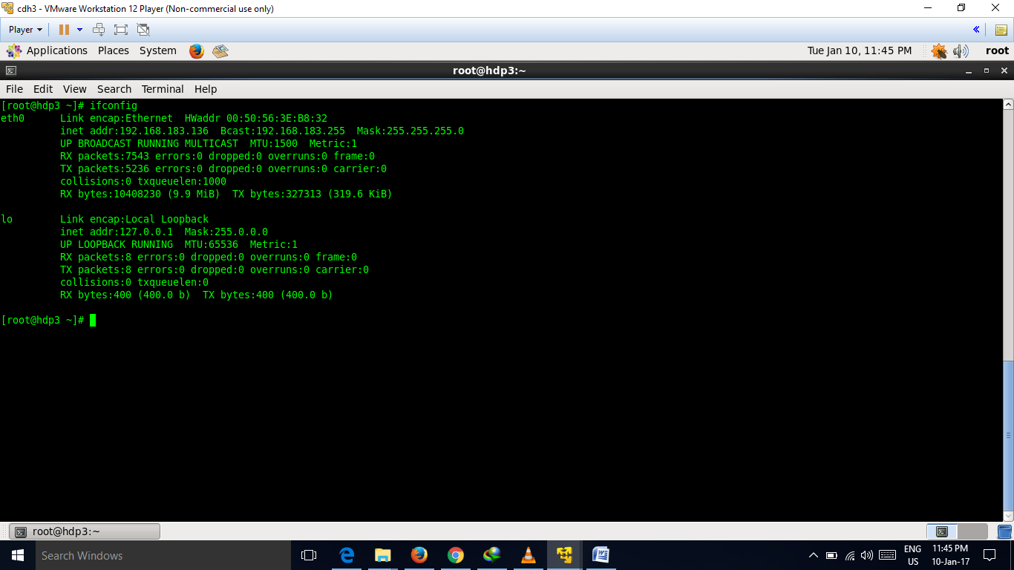

1. Specify cluster Hosts.

Update the ***/etc/hosts*** file

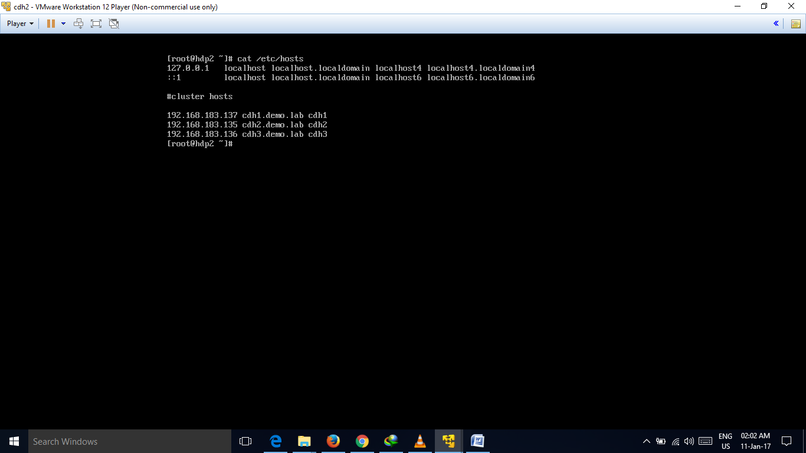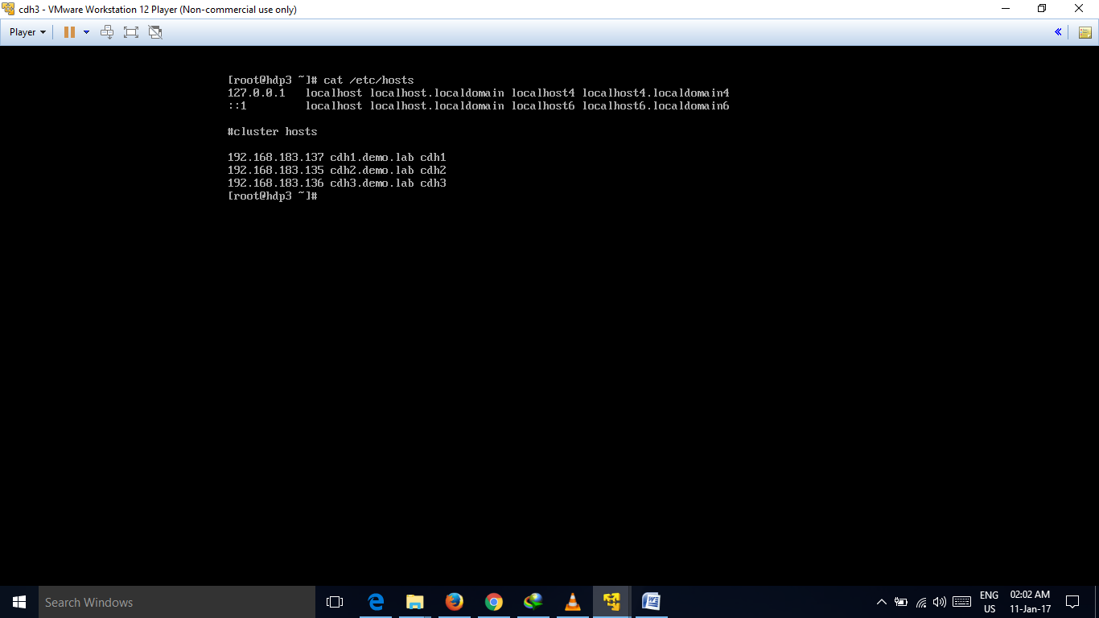

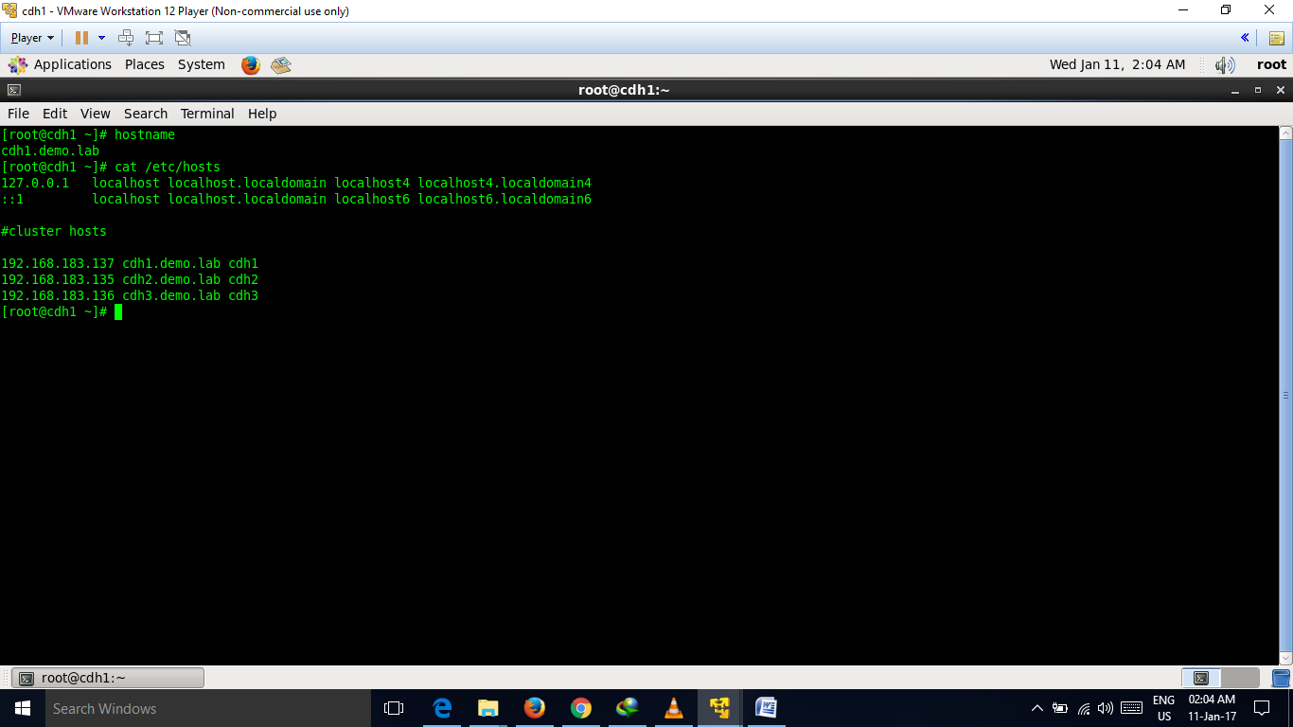

1. In hdp2 and hdp3 , go to ***/etc/inittab*** and make runlevels 3 as default for more utilization of memory in other activities.

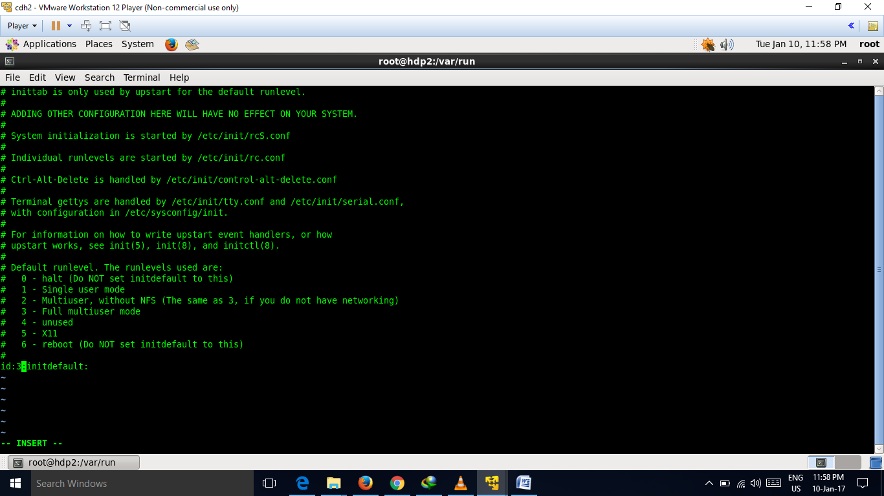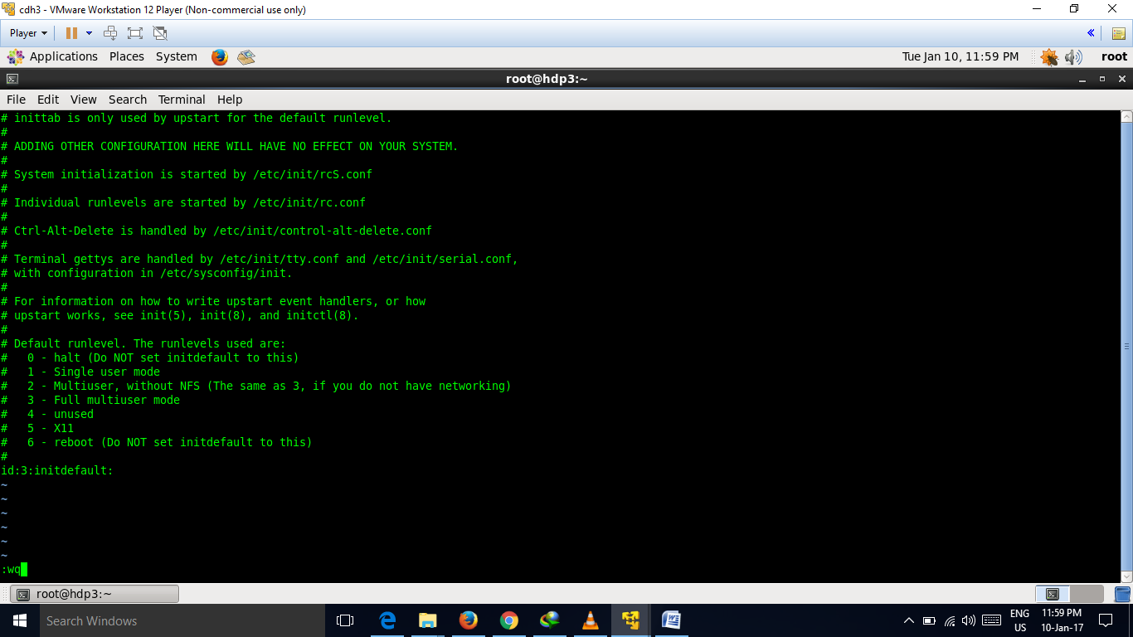

1. Create local repository

Commands-

***yum install httpd***

***rpm –qa | grep –i httpd***

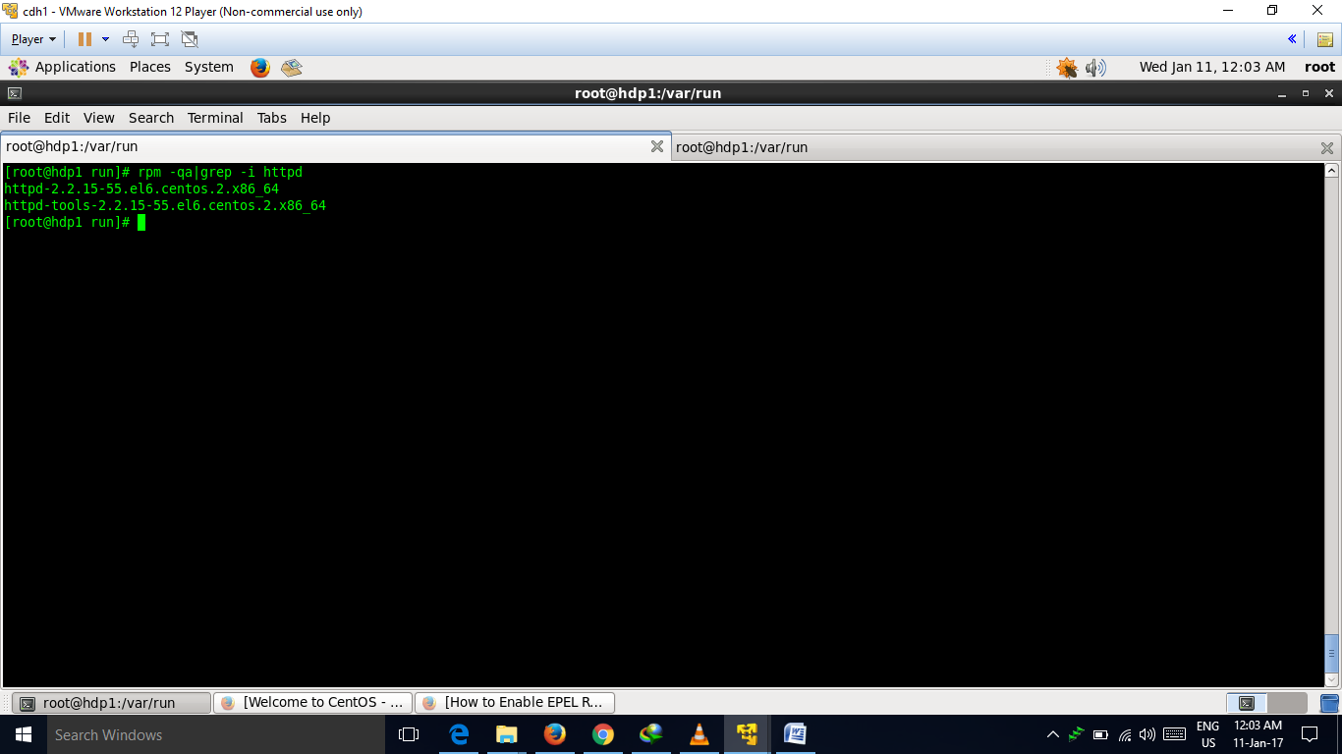

***chkconfig httpd on***

***/etc/init.d/httpd status***

***/etc/init.d/httpd start***

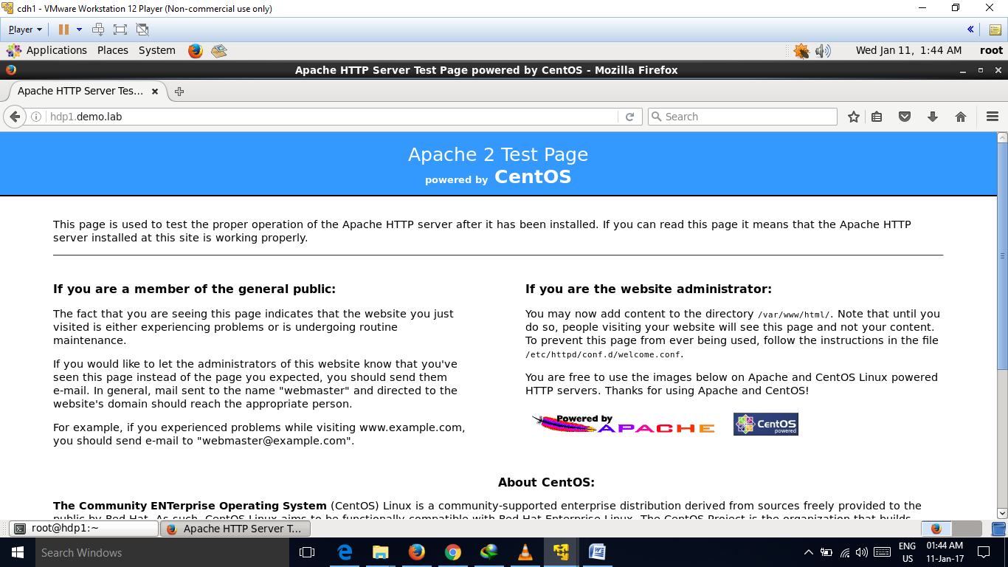

***cd /var/www/html/***

by using winscp tool copy the downloaded files into the vm.

***mkdir cdh5***

***mkdir cm***

copy the downloaded files into this directiories respectively.

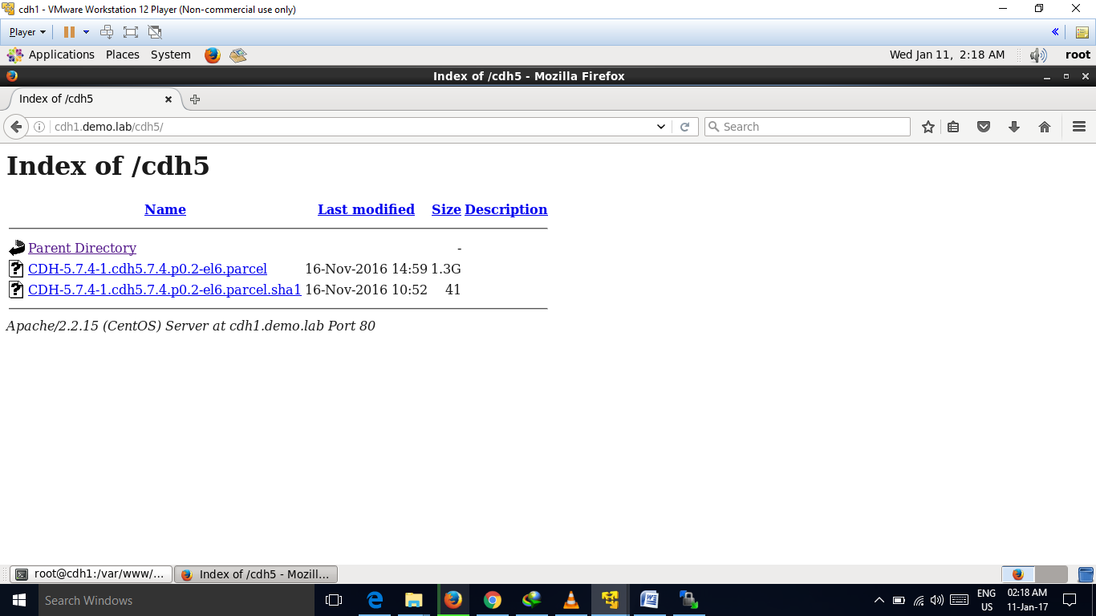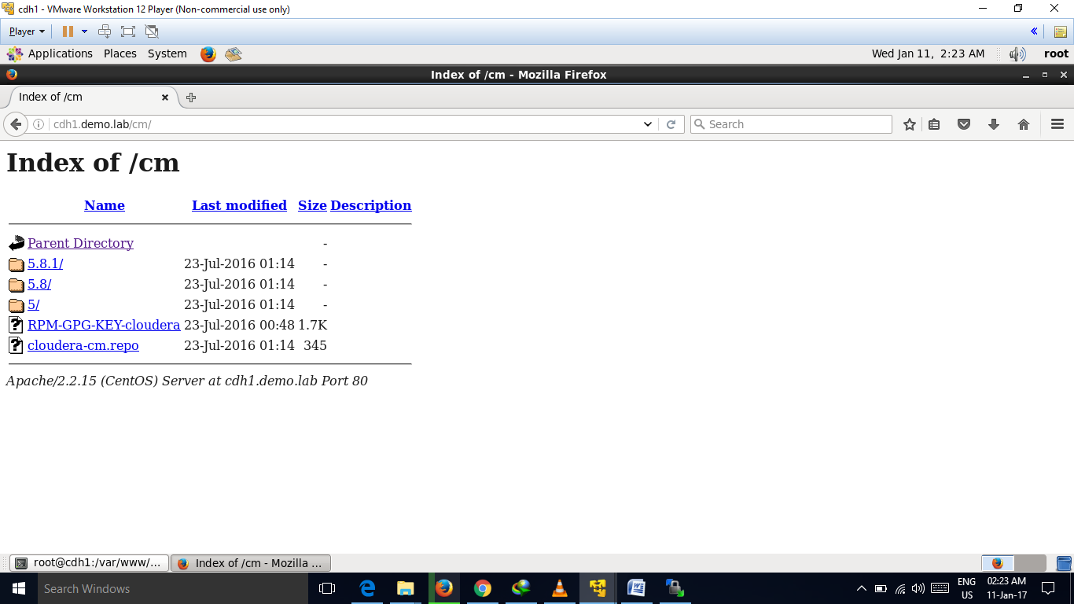

1. SSH credentials

Commands-

***Ssh-keygen***

***ssh-copy-id -i /root/.ssh/id_rsa.pub root@cdh2***

***ssh-copy-id -i /root/.ssh/id_rsa.pub root@cdh3***

***ssh-copy-id -i /root/.ssh/id_rsa.pub root@cdh1***

***vim /etc/ssh/ssh_config***

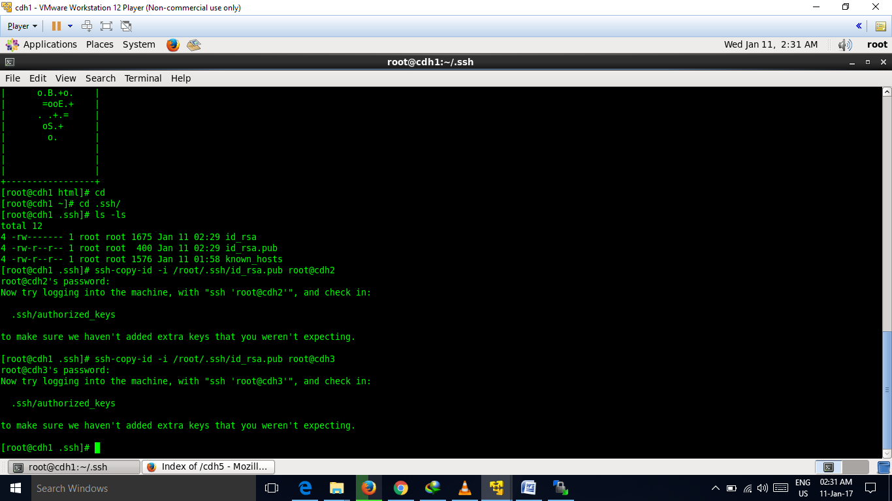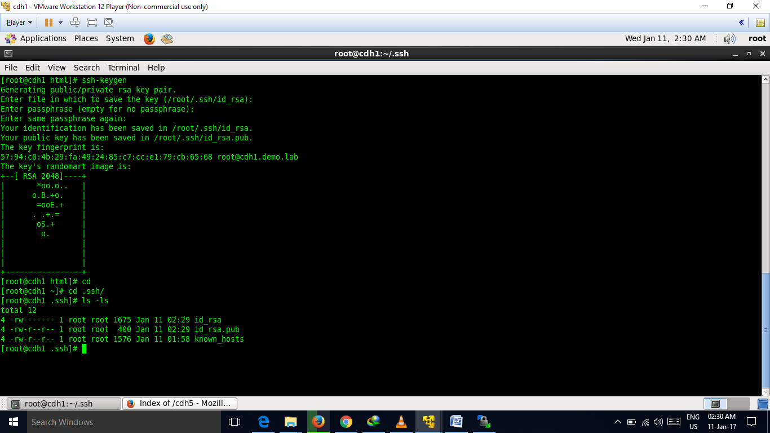  
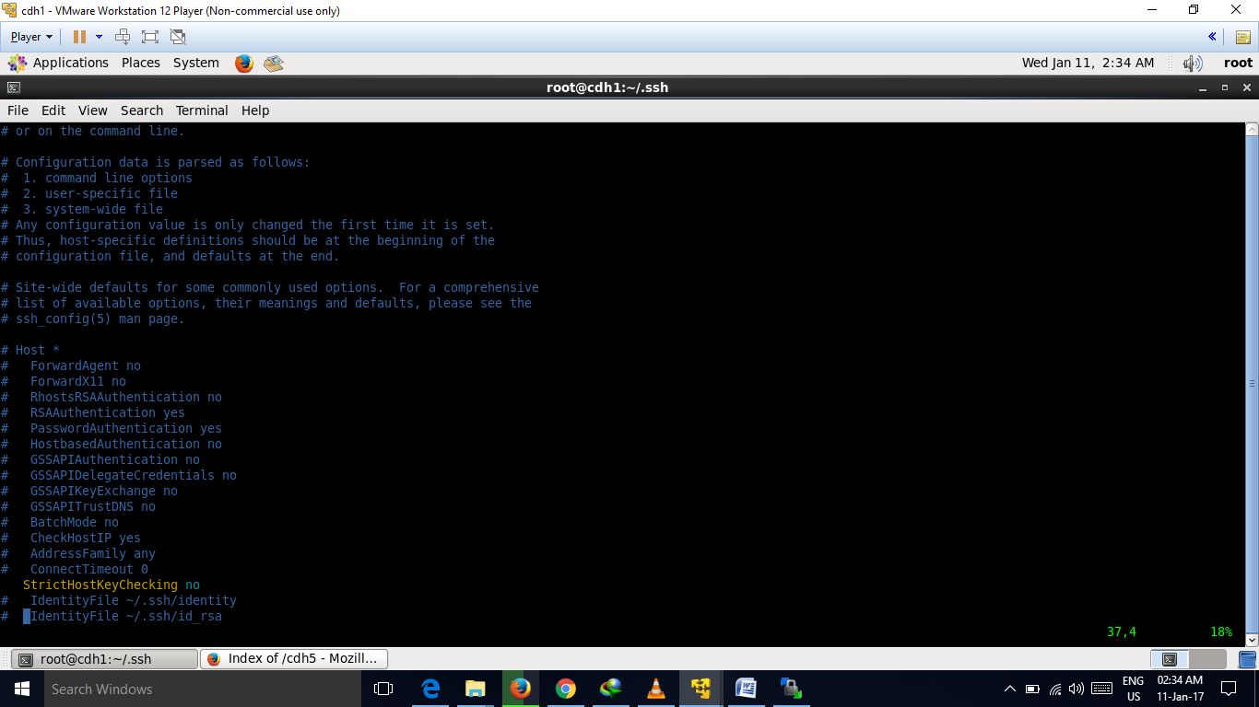

1. Install jdk-7u80-linux-x64.rpm in three machines by following the below step in each machine repectively.

Commands-

***Yum localinstall jdk-7u80-linux-x64.rpm***

***rpm -qa|grep -i jdk***

***rpm -ql jdk-1.7.0_80-fcs.x86_64***

***alternatives --install /usr/bin/java java /usr/java/jdk1.7.0_80/bin/java 210000***

***alternatives --display java***

***java -version***

***vim /etc/profile.d/jdk.sh***

***source /etc/profile.d/jdk.sh***

***env | grep -i java***

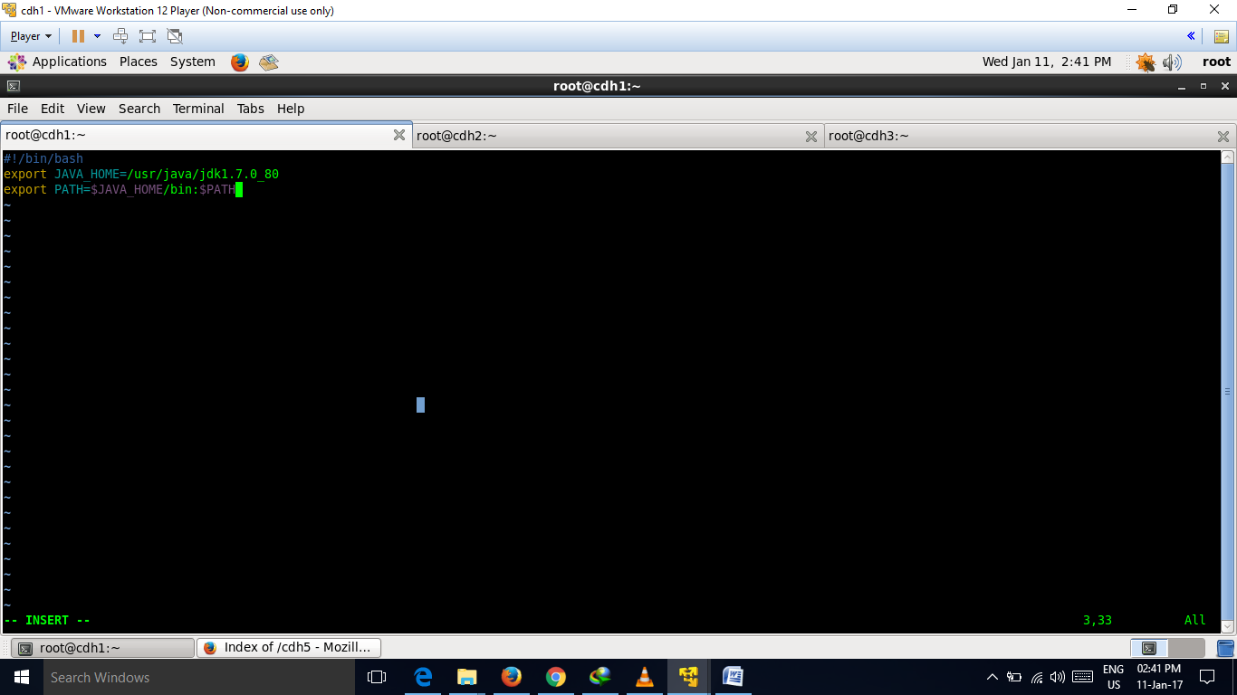

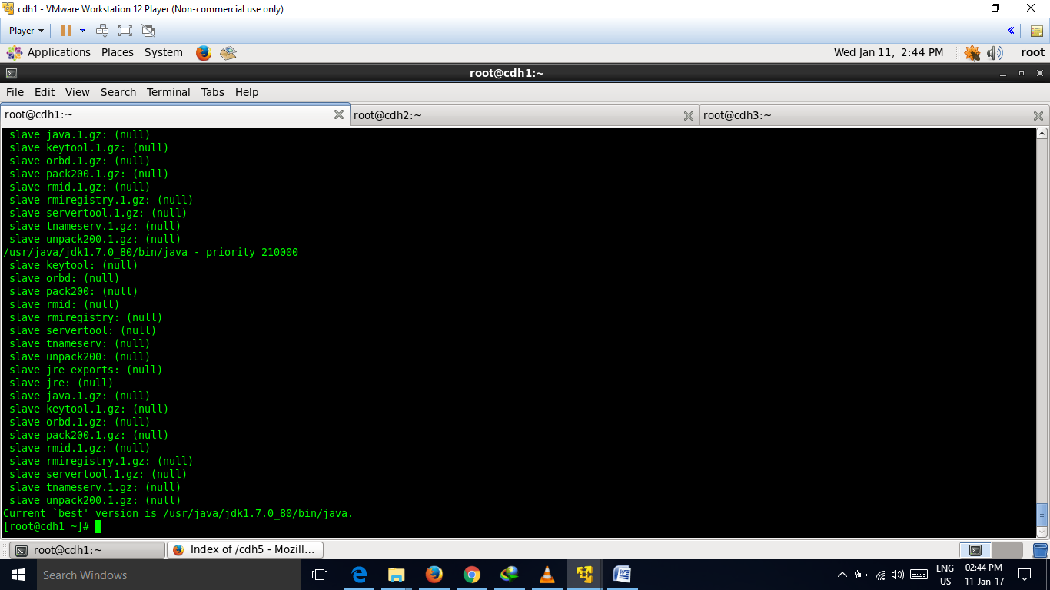

1. Set yum repo for cm

Commands-

***cd /etc/yum.repos.d/***

***wget*** [***http://cdh1.demo.lab/cm/cloudera-cm.repo***](http://cdh1.demo.lab/cm/cloudera-cm.repo)

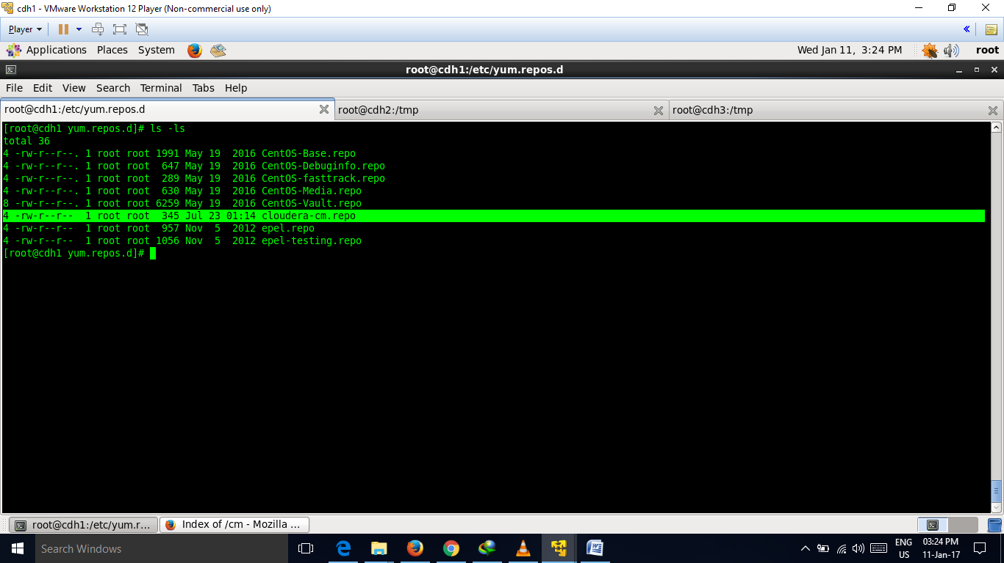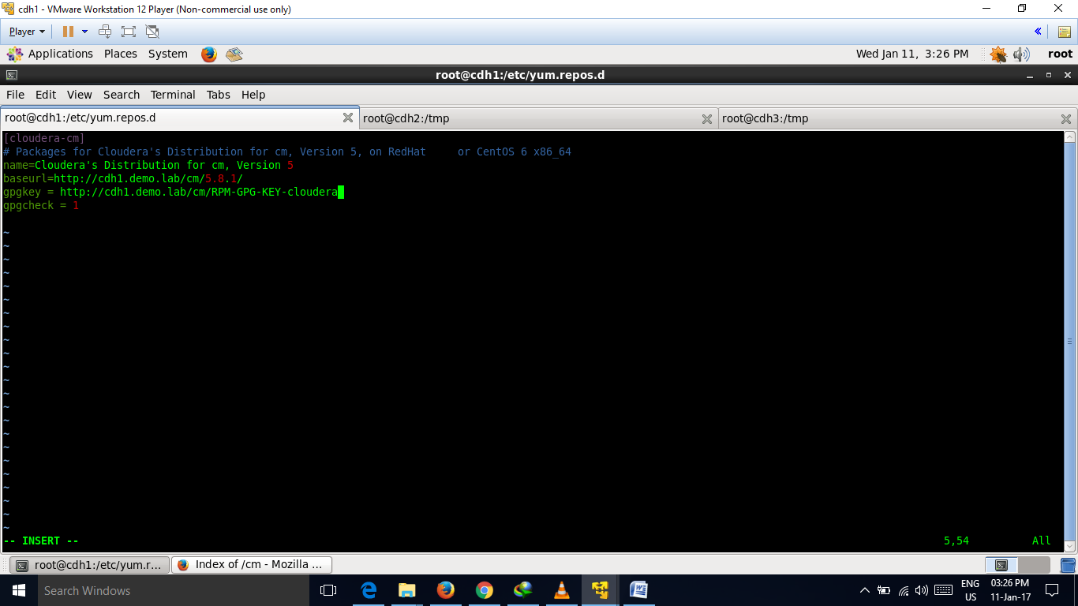

***yum clean all***

***yum repolist***

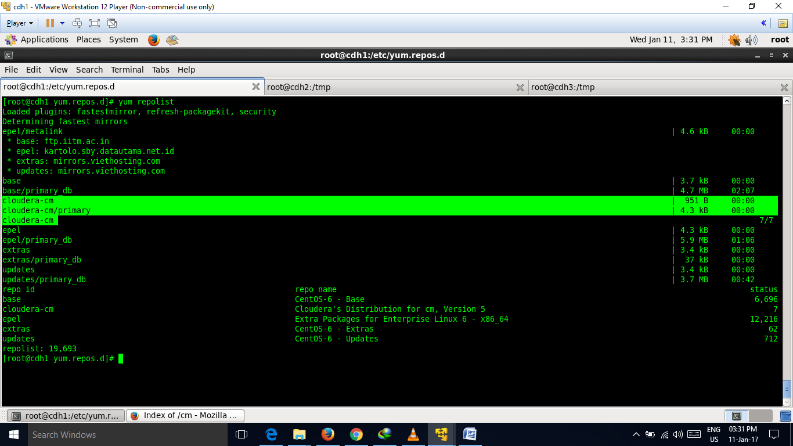

***yum list all | grep cloudera***

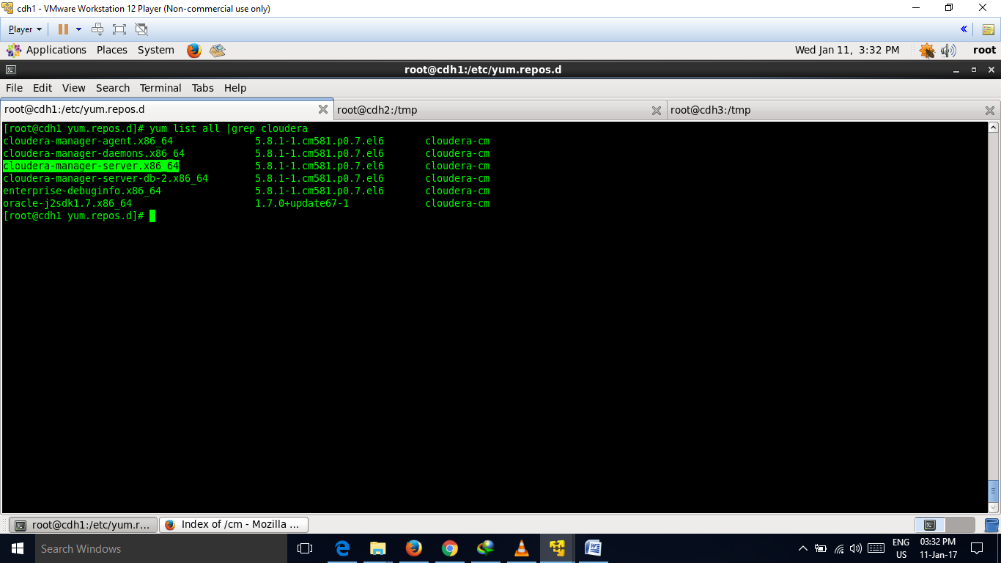

cM installation is of two types**- embedded db and external db**.

For embedded db install cloudera-manager-server-db-2.x86_64 packaga.

For external db install cloudera-manager-server.x86_64 package.

Here we will use external db as it is recomemded in production cluster.

Before installing cloudera-manager-server.x86_64 , we have to install either mysql,postgresql or oracle. Here we will install my sql.

Commands to install my sql-

***yum install mysql-server***

Stop the MySQL server if it is running.

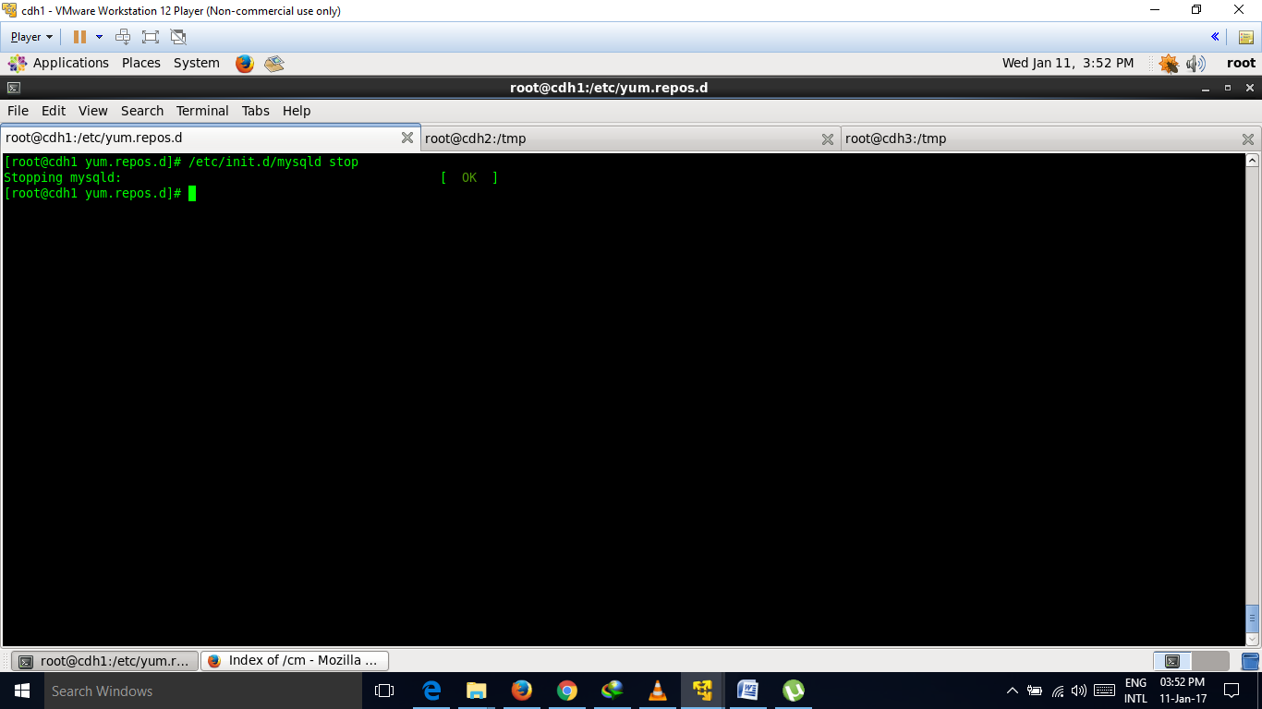

Update ***/etc/my.cnf*** file

[mysqld]

transaction-isolation=READ-COMMITTED

# Disabling symbolic-links is recommended to prevent assorted security risks;

# to do so, uncomment this line:

# symbolic-links=0

key_buffer = 16M

key_buffer_size = 32M

max_allowed_packet = 16M

thread_stack = 256K

thread_cache_size = 64

query_cache_limit = 8M

query_cache_size = 64M

query_cache_type = 1

# Important: see Configuring the Databases and Setting max_connections

max_connections = 550

# log-bin should be on a disk with enough free space

log-bin=/x/home/mysql/logs/binary/mysql_binary_log

# For MySQL version 5.1.8 or later. Comment out binlog_format for older versions.

binlog_format = mixed

read_buffer_size = 2M

read_rnd_buffer_size = 16M

sort_buffer_size = 8M

join_buffer_size = 8M

# InnoDB settings

innodb_file_per_table = 1

innodb_flush_log_at_trx_commit = 2

innodb_log_buffer_size = 64M

innodb_buffer_pool_size = 4G

innodb_thread_concurrency = 8

innodb_flush_method = O_DIRECT

innodb_log_file_size = 512M

[mysqld_safe]

log-error=/var/log/mysqld.log

pid-file=/var/run/mysqld/mysqld.pid

***--------------------------------------------------------------------------------------------------------------------------------***

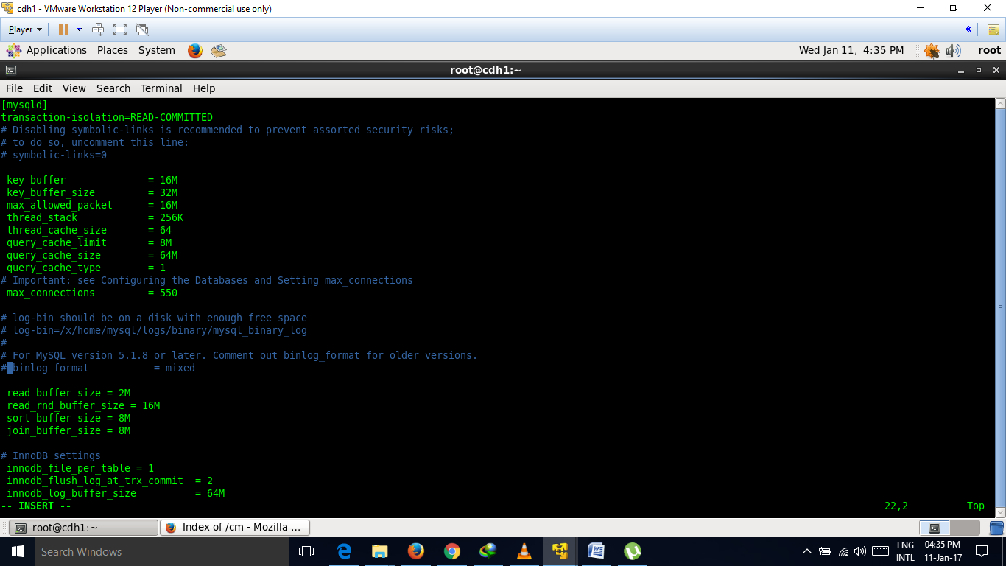

Stop MySQL.

******Start MySQL

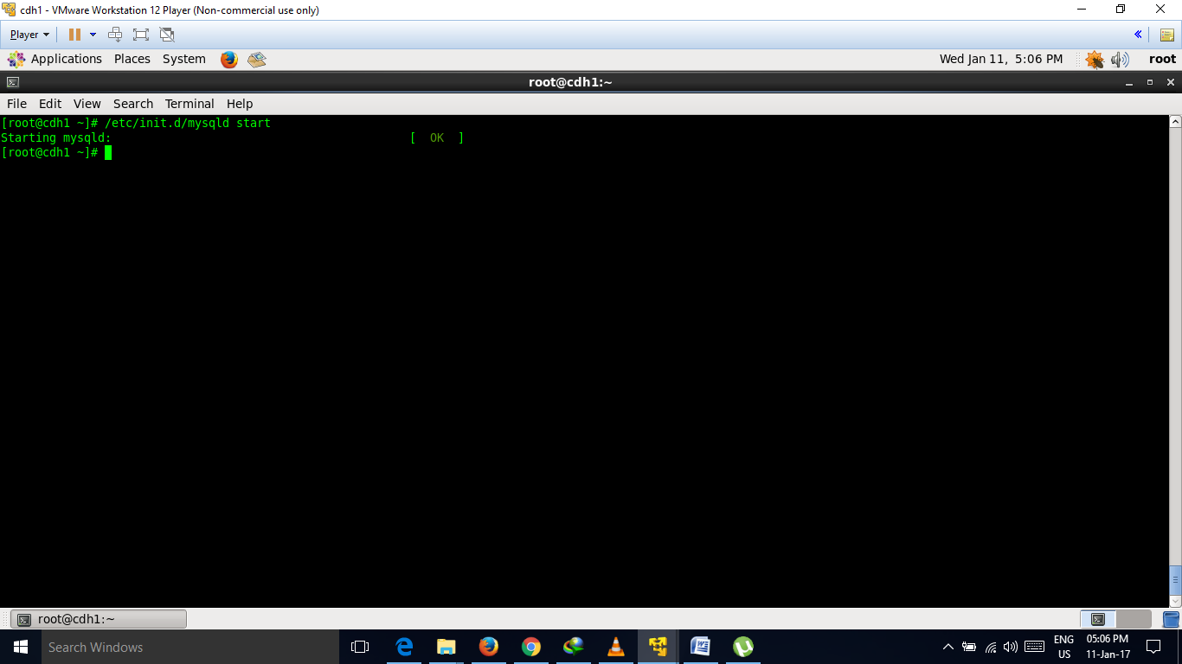

Configuring MySQL

Configure MySQL to use a strong password and to start at boot.

/usr/bin/mysql_secure_installation

[...]

Enter current password for root (enter for none):

OK, successfully used password, moving on...

[...]

Set root password? [Y/n] y

New password:

Re-enter new password:

Remove anonymous users? [Y/n] Y

[...]

Disallow root login remotely? [Y/n] N

[...]

Remove test database and access to it [Y/n] Y

[...]

Reload privilege tables now? [Y/n] Y

All done!

/sbin/chkconfig mysqld on

/sbin/chkconfig --list mysqld

mysqld 0:off 1:off 2:on 3:on 4:on 5:on 6:off

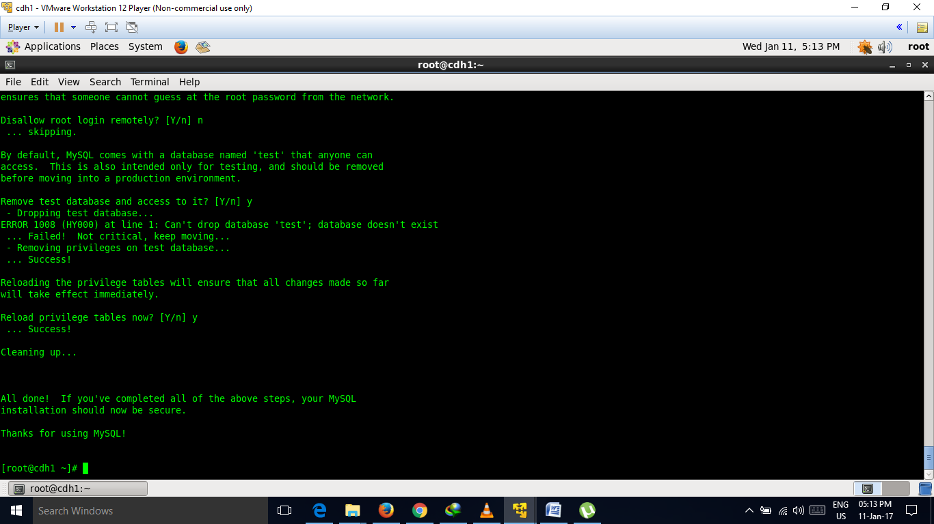

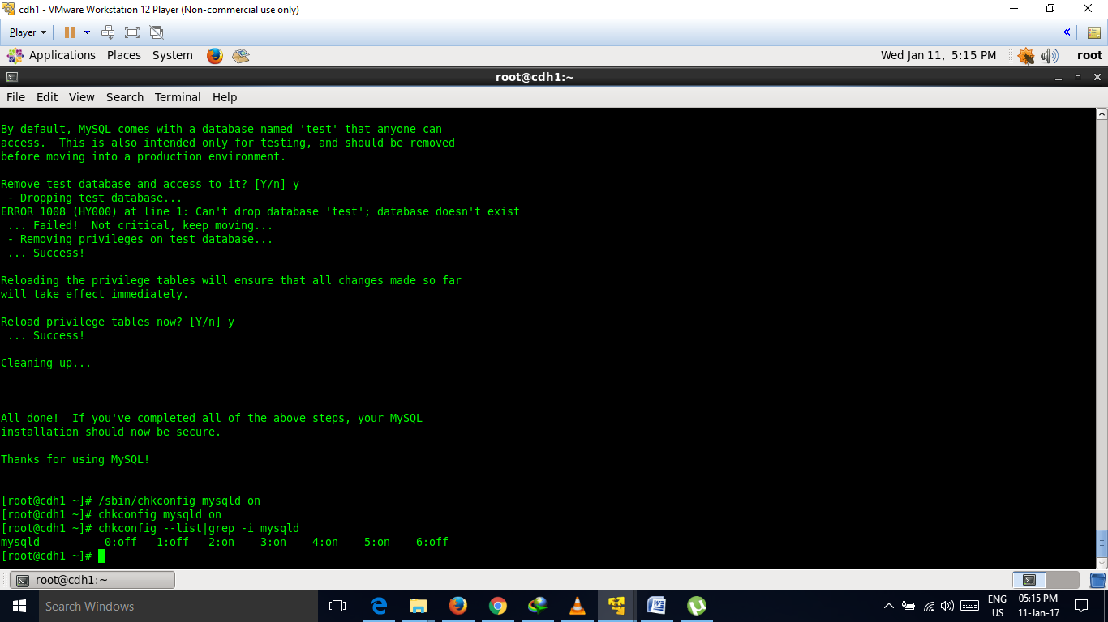

## Installing the MySQL JDBC Connector

Install the JDBC connector on the Cloudera Manager Server host, as well as hosts to which you assign the Activity Monitor, Service Monitor, Report Manager, Host Monitor, Cloudera Navigator, and Hive Metastore Server roles.

Cloudera recommends that you assign all roles that require databases on the same host and install the connector on that host. While putting all such roles on the same host is recommended, it is not required. You could install a role, such as Activity Monitor on one host and other roles on a separate host. In such a case you would install the JDBC connector on each host running roles that access the database.

yum install mysql-connector-java

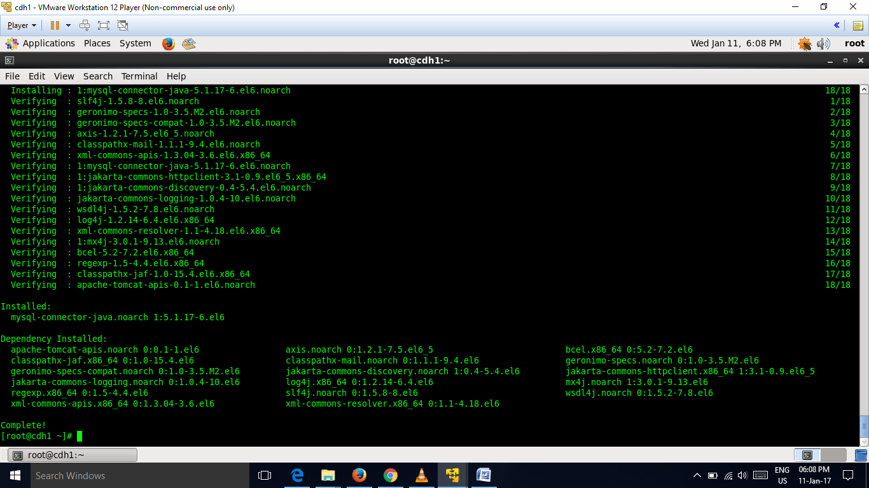

yum install cloudera-manager-server.x86_64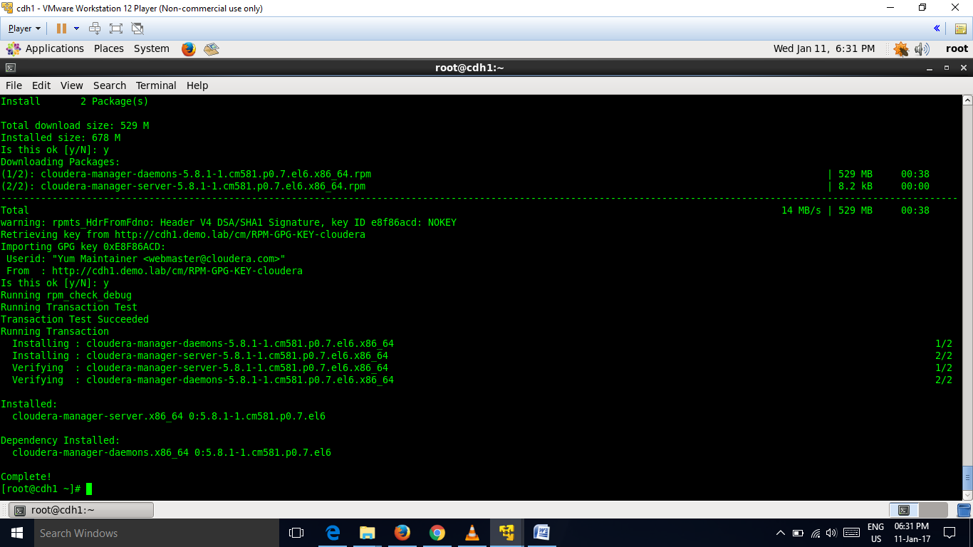

rpm –qa| grep –I cloudera

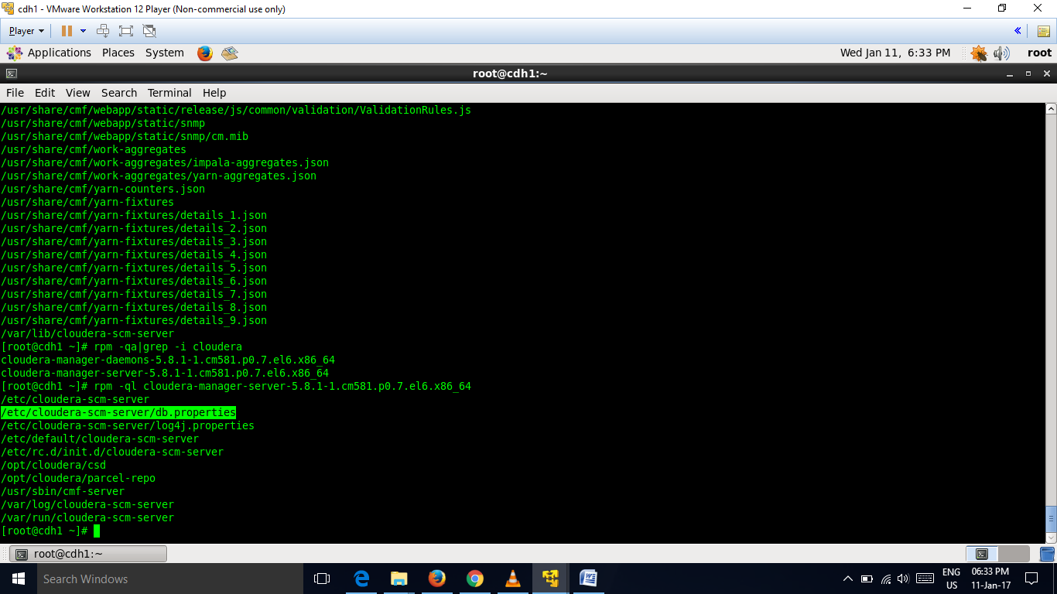

Configure ***/etc/cloudera-scm-server/db.properties*** file

***mysql -p***

***grant all on *.* to 'temp'@'%' identified by 'temp' with grant option;***

***flush privileges;***

***exit***

pattern-/usr/share/cmf/schema/scm_prepare_database.sh mysql -h <mysql_host> -utemp -ptemp --scm-host <cloudera_manager_host> scm scm scm

***for my installation-/usr/share/cmf/schema/scm_prepare_database.sh mysql -h cdh1.demo.lab -utemp -ptemp --scm-host cdh1.demo.lab scm scm scm***

***vi /etc/cloudera-scm-server/db.properties*** 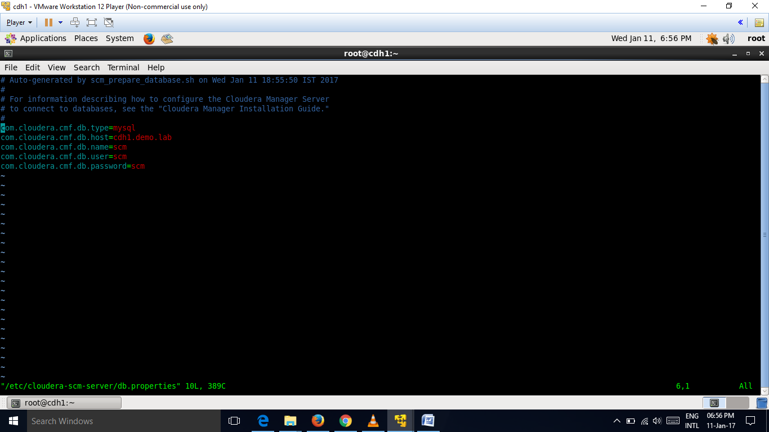

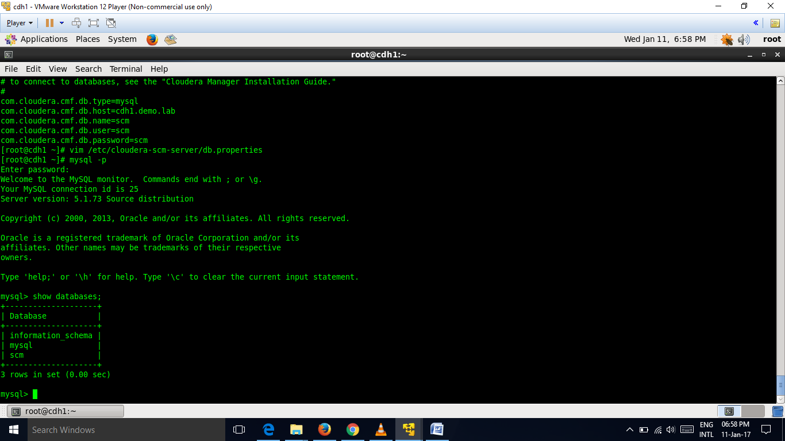

13)now start cloudera services

Command-

/etc/init.d/cloudera-scm-server start

netstat -ntlp|grep -i 7180

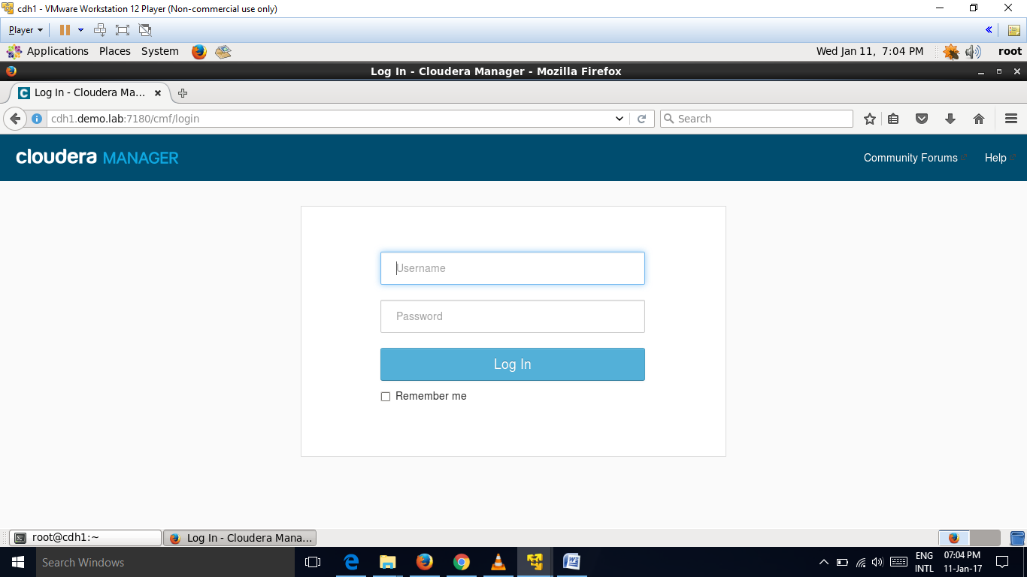

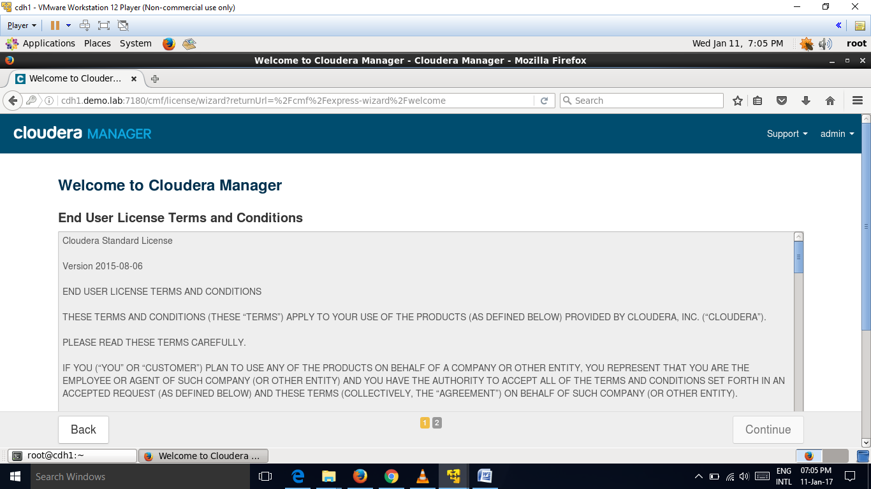

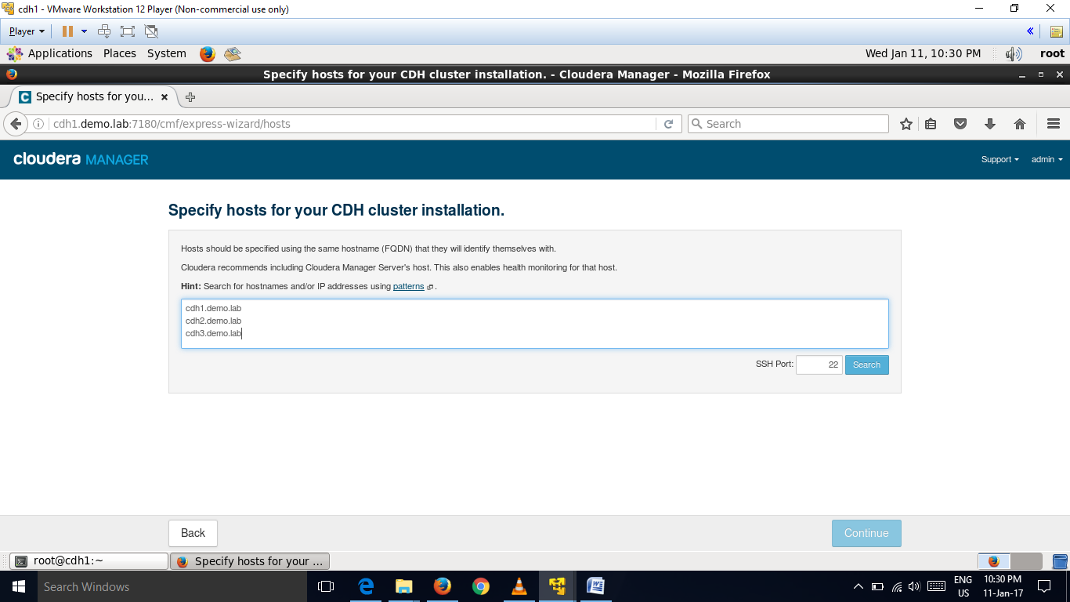

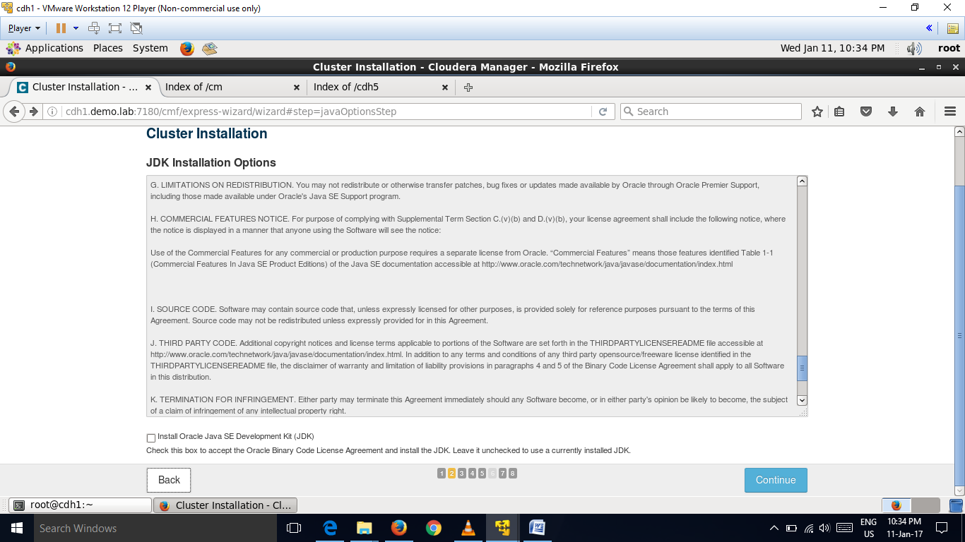

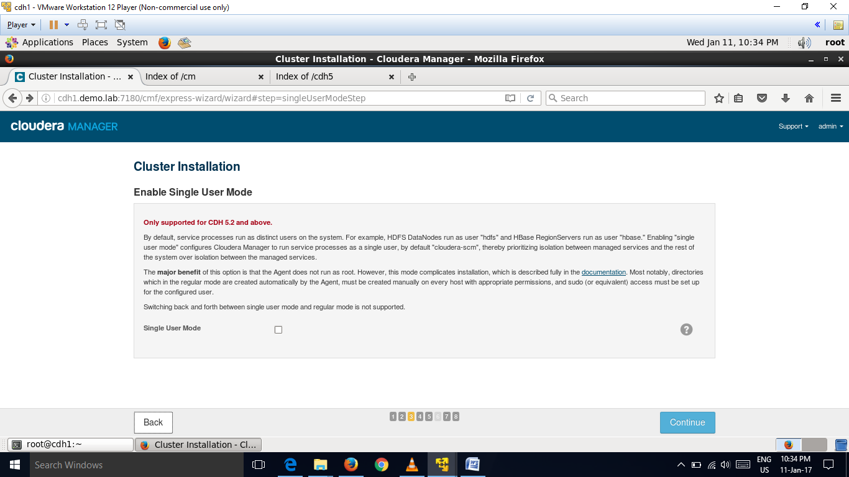

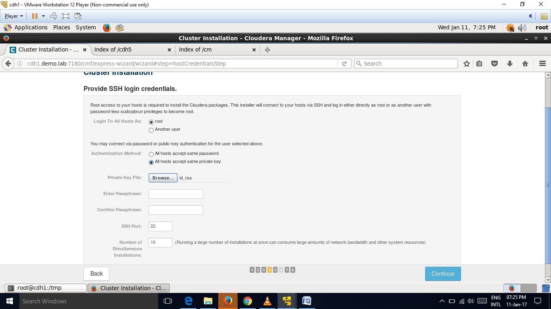

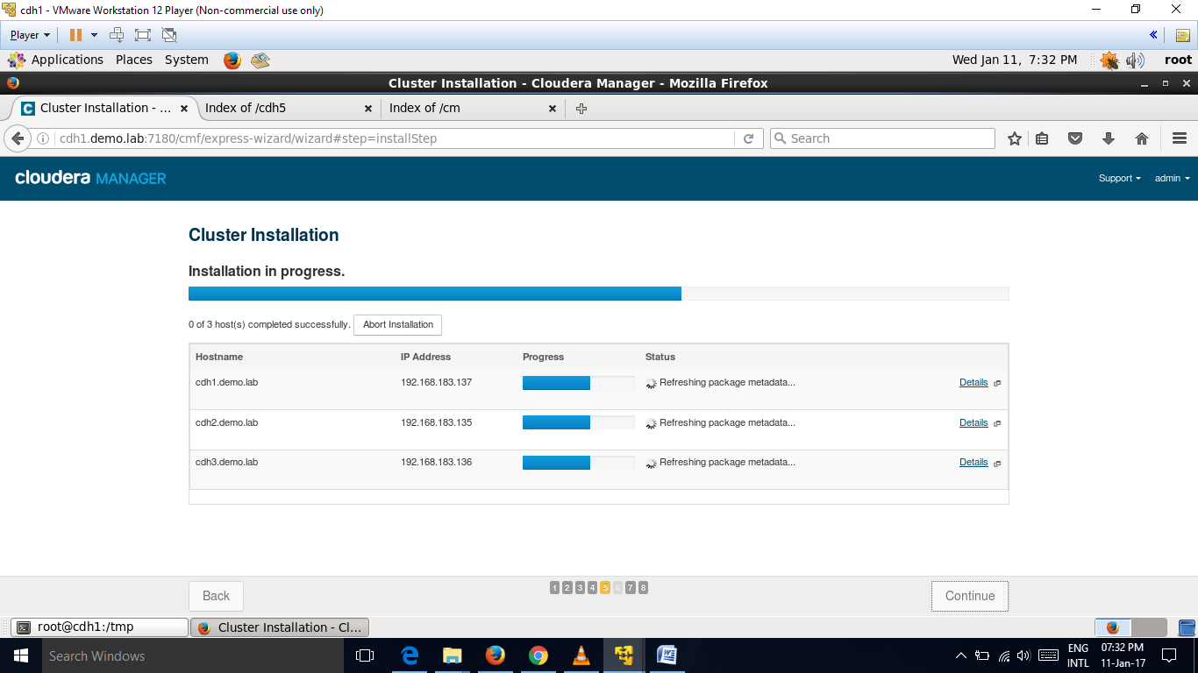

**Cloudera manager run in the port number 7180.**

***/etc/init.d/ntpd start***

***ntpq –pn***

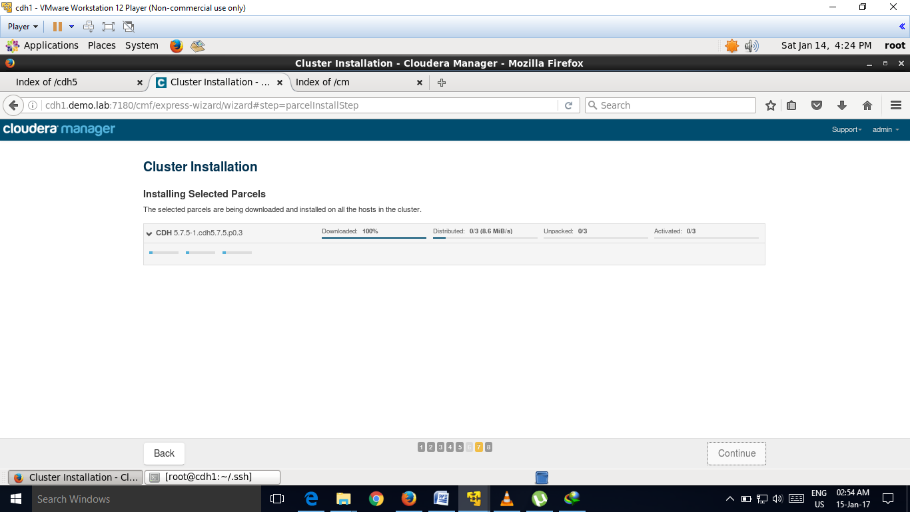

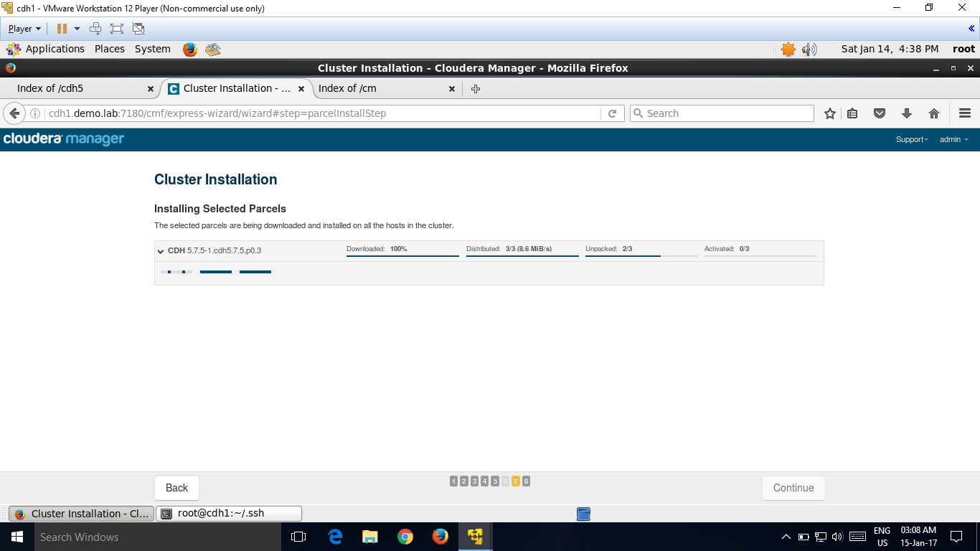

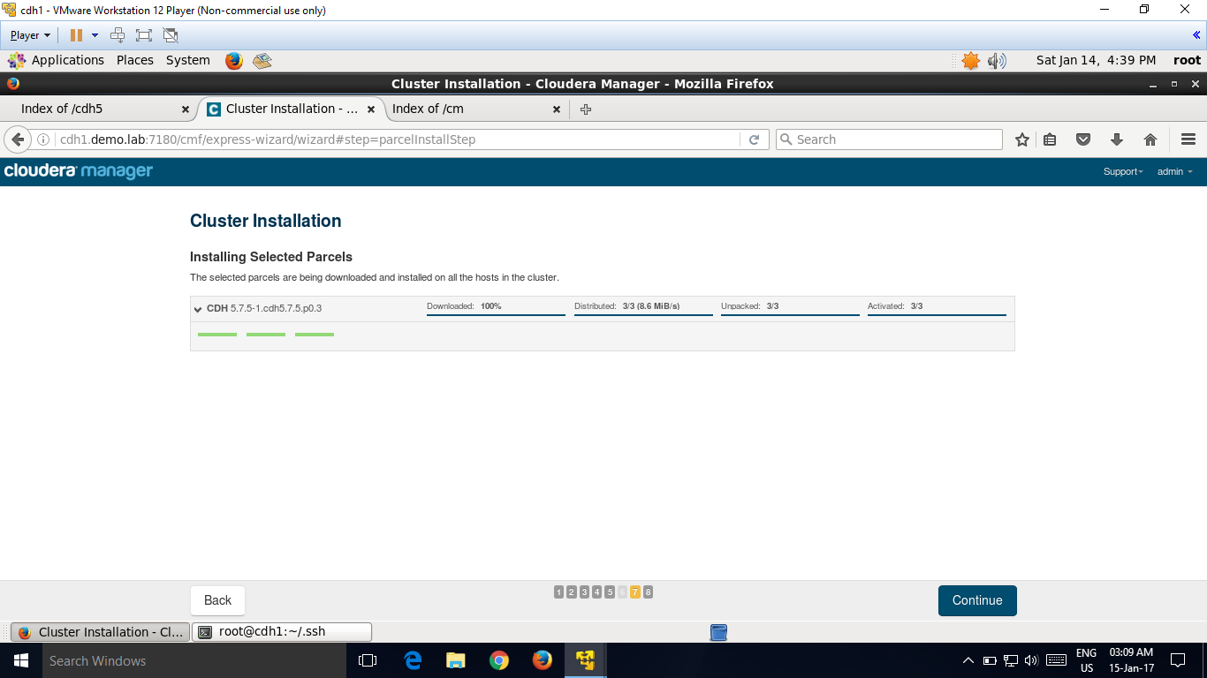

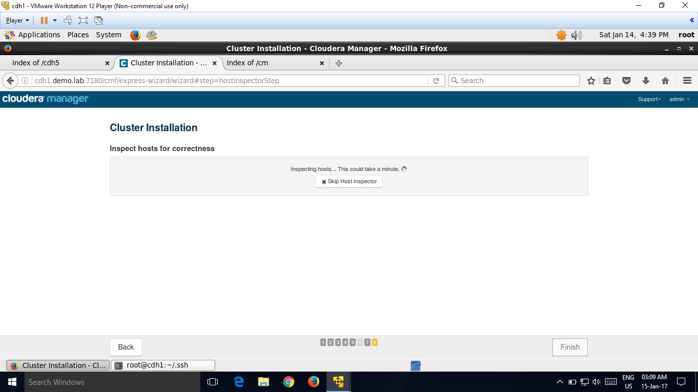

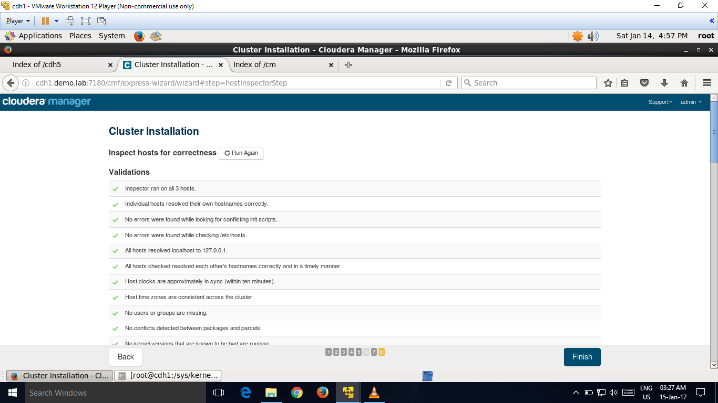

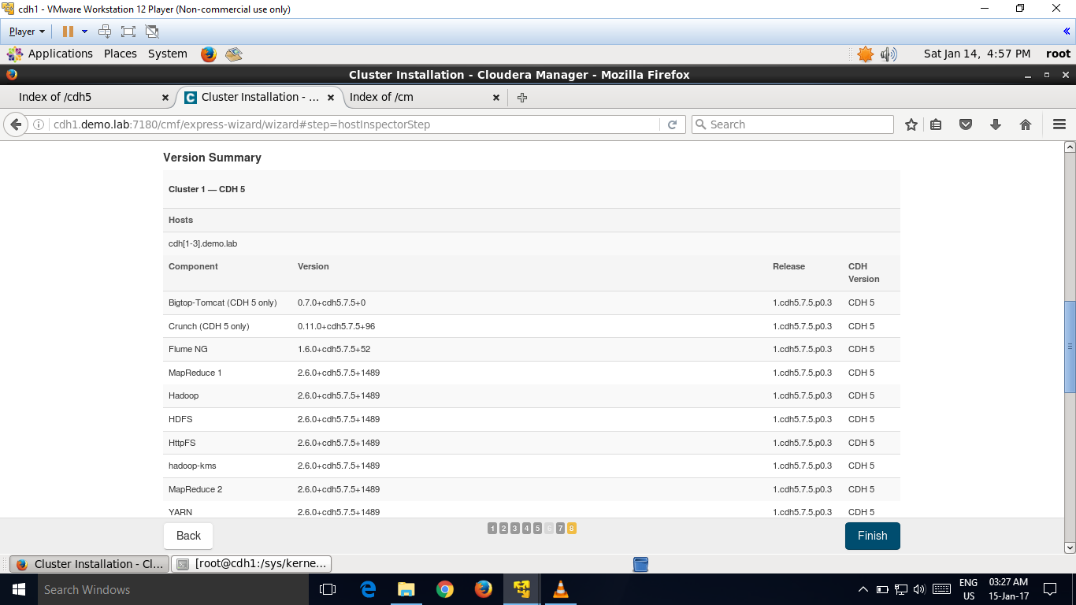

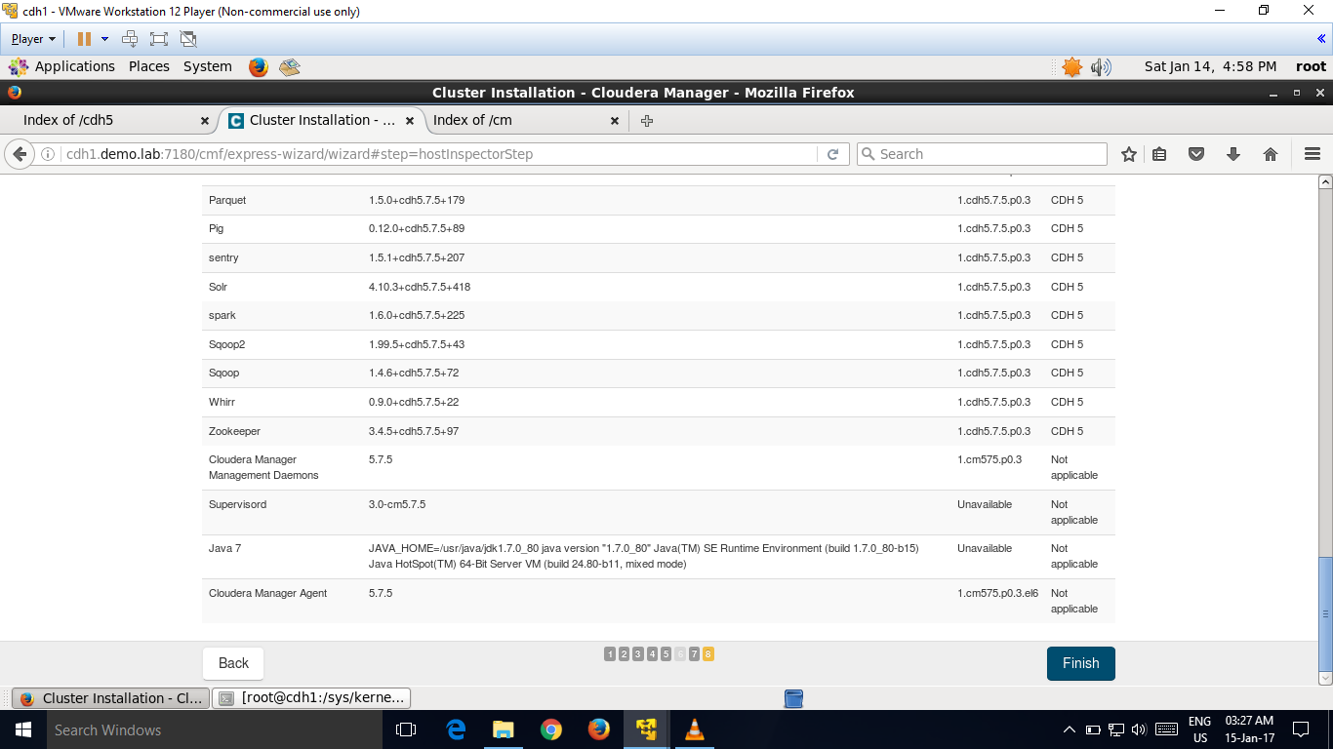

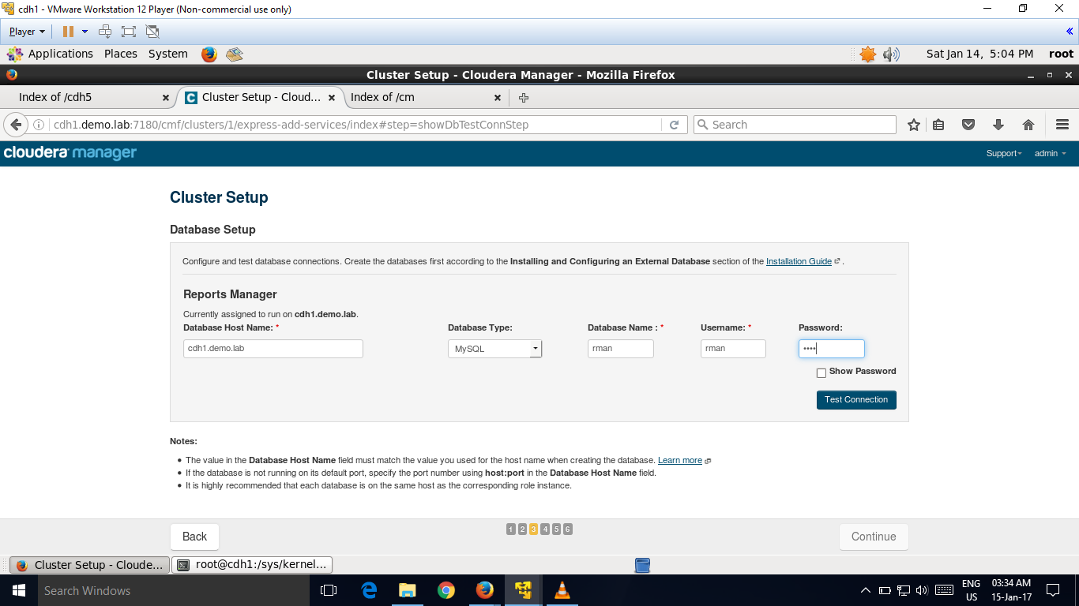

Create databases for the Activity Monitor, Reports Manager, Hive Metastore, Sentry Server, and Cloudera Navigator Audit Server:

mysql> create database *database* DEFAULT CHARACTER SET utf8;

Query OK, 1 row affected (0.00 sec)

mysql> grant all on *database*.* TO '*user*'@'%' IDENTIFIED BY '*password*';

Query OK, 0 rows affected (0.00 sec)

------------------------------------------------------------------------------------------------------------------------------------------

